**LIFESTYLE DISEASE PREDICTION**

## A PROJECT REPORT

***Submitted by,***

**Mr. FAIZ KHAN - 20201CSD0115**

**Mr. JEEVITH JOSEPH CJ - 20201CSD0111**

**Mr. TEJAS GOWDA C - 20201CSD0072**

### *Under the guidance of,*

**Dr.CHANDRASEKAR V**

***in partial fulfillment for the award of the degree of***

**BACHELOR OF TECHNOLOGY**

**IN**

**COMPUTER SCIENCE AND ENGINEERING**

**At**



**PRESIDENCY UNIVERSITY**

**BENGALURU**

**JANUARY 2024**

**PRESIDENCY UNIVERSITY**

**SCHOOL OF COMPUTER SCIENCE ENGINEERING & INFORMATION SCIENCE**

**CERTIFICATE**

This is to certify that the Project report “LIFESTYLE DISEASE PREDICTION” submitted by **FAIZ KHAN (20201CSD0115), JEEVITH JOSEPH CJ (20201CSD0111), TEJAS GOWDA C(20201CSD0072)** in partial fulfilment of requirement for the award of degree of Bachelor of Technology in Computer Science and Engineering (Data Science) is a bonafide work carried out under my supervision.

|  |  |
| --- | --- |
| **Dr.CHANDRASEKAR V**  School of CSE&IS  Presidency University | **Dr. JAYACHANDRAN A**  Professor & HoD  School of CSE&IS  Presidency University |

|  |  |  |
| --- | --- | --- |
| **Dr. C. KALAIARASAN**  Associate Dean  School of CSE&IS  Presidency University | **Dr. L. SHAKKEERA**  Associate Dean  School of CSE&IS  Presidency University | **Dr. SAMEERUDDIN KHAN** Dean  School of CSE&IS  Presidency University |

**PRESIDENCY UNIVERSITY**

**SCHOOL OF COMPUTER SCIENCE ENGINEERING & INFORMATION SCIENCE**

**DECLARATION**

We hereby declare that the work, which is being presented in the project report entitled **LIFESTYLE DISEASE PREDICTION** in partial fulfillment for the award of Degree of **Bachelor of Technology** in **Computer Science and Engineering** , is a record of our own investigations carried under the guidance of Dr.CHANDRASEKAR V**,** **School of Computer Science & Engineering Presidency University, Bengaluru.**

We have not submitted the matter presented in this report anywhere for the award of any other Deg ree.

|  |  |  |
| --- | --- | --- |
| **NAME :** | **ROLL NUMBER :** | **SIGNATURE :** |
| **FAIZ KHAN** | **20201CSD0115** |  |
| **JEEVITH JOSEPH CJ** | **20201CSD0111** |  |
| **TEJAS GOWDA C** | **20201CSD0072** |  |

**ABSTRACT**

The contemporary era witnesses a surge in lifestyle-related diseases, necessitating proactive and personalized health management strategies. The project, titled "Lifestyle Disease Prediction," is an innovative initiative designed to address the growing concern of preventable health conditions stemming from modern lifestyles.

This project leverages advanced data science and machine learning techniques to predict the likelihood of lifestyle-related diseases based on individual behavioral patterns, demographic information, and health history. By analyzing comprehensive datasets, encompassing diverse lifestyle factors, the system aims to provide early indications and risk assessments for diseases associated with sedentary habits, dietary choices, and stress.

The project encompasses the development of robust predictive models, employing algorithms such as decision trees, ensemble methods, and neural networks. It focuses on the integration of real-time health data, wearable device inputs, and historical health records to enhance the accuracy and reliability of predictions.

Key features include a user-friendly interface for data input, dynamic risk assessment, and personalized health recommendations. The project's goal is to empower individuals to make informed decisions about their lifestyles, facilitating proactive health management and disease prevention.

Key features used in the prediction model include dietary habits, physical activity levels, smoking status, alcohol consumption, family medical history, and genetic markers. The model is trained on a diverse dataset to ensure robust predictions across different demographics and geographic regions. Continuous updates to the model are made possible through real-time health monitoring, ensuring adaptability to changing lifestyle patterns.

The "Lifestyle Disease Prediction" project contributes to the evolving field of preventive healthcare by harnessing the potential of data science to create a tool that aids individuals in adopting healthier lifestyles and mitigating the risks associated with modern-day living.

**ACKNOWLEDGEMENT**

I would like to express my sincere gratitude to several individuals and our organization for supporting me through this project.

We express our sincere thanks to our respected dean Dr. Md. Sameeruddin Khan, Dean, School of Computer Science Engineering & Information Science, Presidency University for getting us permission to undergo the project.

We record our heartfelt gratitude to our beloved Associate Deans Dr. Kalaiarasan C and Dr. Shakkeera L, School of Computer Science Engineering & Information Science, Presidency University and Dr.Jayachandran A Head of the Department, School of Computer Science Engineering & Information Science, Presidency University for rendering timely help for the successful completion of this project.

We are greatly indebted to our guide Dr.CHANDRASEKAR V, School of Computer Science Engineering & Information Science, Presidency University for her inspirational guidance, and valuable suggestions and for providing us a chance to express our technical capabilities in every respect for the completion of the project work.

We would like to convey our gratitude and heartfelt thanks to the University Project-II Coordinators Dr. Sanjeev P Kaulgud, Dr. Mrutyunjaya MS and also the department Project Coordinator Ms. Manasa C M.I am also grateful to Dr. K Susheel Kumar for their consistent support and assistance during this project.

Thanks for all your encouragement!

**FAIZ KHAN**

**JEEVITH JOSEPH CJ**

**TEJAS GOWDA C**

**LIST OF TABLES**

|  |  |  |  |
| --- | --- | --- | --- |
| **Sl. No.** | **Table Name** | **Table Caption** | **Page No.** |
| 1 | Table 1 | Diabetes Prediction Data | 17 |
| 2 | Table 2 | Accuracy of All Models for Diabetes Prediction | 48 |
| 3 | Table 3. | Ensemble Accuracy for Diabetes Prediction | 49 |
| 4 | Table 4. | Accuracy of Hybrid Models | 50 |
| 5 | Table 5. | Heart Disease Prediction Data | 51 |
| 5 | Table 6. | Statistical Summary of Heart Disease Data | 60 |
| 6 | Table 7. | Evaluation Metrics for All the Hybrid Models | 62 |
| 7 | Table 8. | Ensemble Accuracy of Heart Disease Prediction | 65 |
| 8 | Table 9. | Ensemble Accuracy of CKD Prediction | 70 |
| 9 | Table 10. | CNN Accuracy for Pneumonia Prediction | 72 |

**LIST OF FIGURES**

|  |  |  |  |
| --- | --- | --- | --- |
| **Sl. No.** | **Figure Name** | **Caption** | **Page No.** |
| 1. | Figure 1. | Pair plot for diabetes prediction for diabetes | 12 |
| 2 | Figure 2. | Plotting the data using count plot for diabetes | 18 |
| 3 | Figure 3 | Distribution of data using histogram for diabetes | 19 |
| 4 | Figure 4 | Plotting the Confusion matrix for diabetes data for diabetes | 19 |
| 5 | Figure 5 | Plotting the subplot for diabetes | 20 |
| 6 | Figure 6 | Detecting the outliers for diabetes | 25 |
| 7 | Figure 7 | Normalizing the data using Quantile Transform for diabetes | 27 |
| 8 | Figure 8 | Plotting the diabetes data for diabetes | 28 |
| 9 | Figure 9 | Defining all the Classification Alogorithm for diabetes | 29 |
| 10 | Figure 10 | Fitting the model for all the hybrid models defined for diabetes | 30 |
| 11 | Figure 11 | Making predictions for the traning data  for diabetes | 32 |
| 12 | Figure 12 | Comparision of Accuracy and Precision for different modes for diabetes | 32 |
| 13 | Figure 13 | Fiting the model using ensemble  for diabetes | 33 |
| 14 | Figure 14 | Classificaton Report for Diabetes Prediction | 33 |
| 15 | Figure 15 | Confusion matrix of predicted data for diabetes prediction for heart disease | 34 |
| 16 | Figure 16 | Pair plot for heart disease data(relationship between the data) | 36 |
| 17 | Figure 17 | Finding the missing values for heart disease | 37 |
| 18 | Figure 18 | Count plot of given heat disease data | 38 |
| 19 | Figure 19 | Distribution of the data using histogram  for heart disease | 40 |
| 20 | Figure 20 | Correlation of Heart disease data | 41 |
| 21 | Figure 21 | Decting the Outliers for heart disease | 42 |
| 22 | Figure 22 | Interactive 3D scatter plot for heart disease | 43 |
| 23 | Figure 23 | Comparison of Accuracy and Precision for Different Models for heart disease | 46 |
| 24 | Figure 24 | Performance Evaluation of Heart Disease Prediction for heart disease | 48 |
| 25 | Figure 25 | Confusion Matrix of Predicted Model  for heart disease | 50 |

**TABLE OF CONTENTS**

|  |  |  |
| --- | --- | --- |
| Chapter No. | Title | Page No. |
|  | Title Page | i |
|  | Certificate | ii |
|  | Declaration | iii |
|  | Abstract | iv |
|  | Acknowledgement | v |
|  | List Of Tables | vi |
|  | List Of Figures | vii |
| 1. | Introduction | 1 |
| 2. | Literature Survey | 3 |
| 3 | Research Gaps OF Existing Methods | 7 |
| 4 | Proposed Methodology | 12 |
| 5 | Objective | 14 |
| 6 | **Lifestyle Disease Prediction**  **Diabetes Prediction**  Data Collection and Preprocessing  Data Sourcing  1.2 Data Cleaning  1.3 Data Split  Exploratory Data Analysis (EDA)  2.1 Descriptive Analysis  2.2 Visualization  Feature Selection and Engineering  3.1 Feature Importance  Algorithm Selection  4.1 Model Implementation  Model Evaluation  5.1 Comparative Analysis and Evaluation  5.2 Best Model Selection  **Heart Disease Prediction**  Data Collection and Preprocessing  1.1Data Sourcing  1.2Data Cleaning  1.3Data Split  Exploratory Data Analysis (EDA)  2.1 Descriptive Analysis  2.2 Visualization  Feature Selection and Engineering  3.1 Feature Importance  Algorithm Selection  4.1 Model Implementation  Model Evaluation  5.1 Comparative Analysis and Evaluation  5.2 Best Model Selection  **Chronic Kidney Disease Prediction**  Data Collection and Preprocessing  1.1Data Acquisition  1.2 Image Preprocessing  1.3 Data Augmentation  Exploratory Data Analysis (EDA)  2.1 Descriptive Analysis  2.2 Visualization of Data  Feature Selection and Engineering  3.1 Feature Importance  Algorithm Selection  4.1 Model Implementation  Model Evaluation  5.1 Comparative Analysis and Evaluation  5.2 Best Model Selection  **Pneumonia Detection using CNN model**  Data Collection and Preprocessing  1.1Data Acquisition  1.2 Image Preprocessing  1.3 Data Augmentation  Exploratory Data Analysis (EDA)  2.1 Descriptive Analysis  2.2 Visualization of Pneumonia Images  Model Architecture Design  3.1 Convolutional Neural Network (CNN) Architecture  3.2 Transfer Learning (if applicable)  Model Implementation  4.1 Building the CNN Model  4.2 Compilation of the Model  Training the CNN Model  5.1 Data Split for Training and Validation  5.2 Model Training  5.3 Monitoring Training Progress  Model Evaluation  6.1 Evaluation Metrics (accuracy, precision, recall)  6.2 Confusion Matrix Analysis  Fine-Tuning and Optimization  7.1 Hyperparameter Tuning 7  7.2 Model Fine-Tuning  Interpretation and Visualization  8.1 Visualizing Activations or Filters  8.2 Interpretability of CNN Predictions  Testing and Inference  9.1 Using Test Data  9.2 Model Inference on New Images  Comparative Analysis and Evaluation  10.1 Benchmarking Against Existing Models  10.2 Comparative Analysis of Model Performance | 15  18  30 |
| 7 | Timeline For Execution of Project | 44 |
| 8 | Outcomes  1. Identification of Optimal Algorithms  2. Performance Metrics Insights  3. Model Interpretability | 45 |
| 9 | Results And Discussions | 48 |
| 10 | Conclusion | 51 |

**CHAPTER-1**

**INTRODUCTION**

.

In an era where data and technology are transforming every aspect of our lives, healthcare is no exception. With the rising prevalence of lifestyle-related diseases, such as diabetes, heart disease, and obesity, the need for innovative and cost-effective preventive healthcare solutions has never been more pressing. Early detection and intervention are key to reducing the human and economic toll of these diseases. This project sets out to explore a novel approach to healthcare that harnesses the power of detailed demographic and vital statistics to predict the likelihood of lifestyle diseases, enabling timely interventions and substantial cost savings in the long run.

This project will help the user to overcome the lifestyle diseases which are in themselves a big threat to humans, will reduce the unawareness about the diseases and will help people to remain healthy which is of utmost importance in today’s fast-growing world. In this project, we will delve into the methods and technologies necessary to harness the potential of data-driven predictive modeling in healthcare. By integrating technology, data, and medical expertise, we aim to pave the way for a healthcare system that not only extends lives but also makes them healthier and more affordable. This proactive approach holds the promise of not only enhancing the quality of life for individuals but also reducing the economic burden of lifestyle diseases on healthcare systems worldwide.

Among the prominent lifestyle diseases, this exploration delves into the complexities of diabetes, heart disease, chronic kidney disease, and pneumonia. Each of these conditions is not only shaped by genetic predispositions but also intricately connected to the way individuals live their lives

**Diabetes**

Diabetes, a hallmark lifestyle disease, is intricately linked to long-term behavioral patterns. Lifestyle choices, including diet and physical activity, significantly influence the development of this chronic metabolic disorder. Subtopic 1 sheds light on the multifaceted nature of diabetes, from the impact of genetic predispositions to the crucial role of lifestyle choices and environmental influences. Recognizing the intricate relationship between lifestyle and diabetes prevalence is essential for designing effective preventive strategies.

The application of ensemble methods in diabetes prediction has gained prominence. Combining the strengths of multiple predictive models, ensemble techniques enhance the robustness and accuracy of diabetes predictions. Methods such as Random Forests and Gradient Boosting, when integrated into an ensemble framework, offer a more comprehensive approach to understanding and predicting diabetes risk factors.

**Heart Disease**

Heart disease, often exacerbated by lifestyle factors, represents a culmination of cardiovascular disorders influenced by how individuals live their lives. Subtopic 2 navigates through the diverse spectrum of heart diseases, emphasizing the role of lifestyle choices in conditions such as coronary artery disease, heart failure, and arrhythmias. Understanding the connection between lifestyle and heart disease complexity guides healthcare professionals in formulating targeted interventions for prevention and treatment.

Ensemble methods have proven effective in enhancing the accuracy of heart disease prediction models. By combining the predictive capabilities of various algorithms, ensemble techniques such as bagging and boosting offer a synergistic approach. Integrating diverse models, including decision trees and support vector machines, into an ensemble framework empowers healthcare professionals with more reliable tools for risk assessment and treatment planning.

**Chronic Kidney Disease**

Chronic Kidney Disease (CKD) is a prevalent health condition influenced significantly by lifestyle factors, representing a broad range of disorders affecting the kidneys. This note explores the intricate relationship between lifestyle choices and CKD, shedding light on the multifaceted nature of the disease. Lifestyle factors such as diet, physical activity, and substance abuse play pivotal roles in the development and progression of CKD, underscoring the importance of preventive measures.

The link between lifestyle and CKD complexity is crucial for healthcare professionals seeking to address the multifactorial aspects of this condition. Lifestyle choices impact risk factors associated with CKD, including hypertension and diabetes. Suboptimal lifestyle habits can exacerbate these risk factors, contributing to the onset and progression of CKD.

Ensemble methods, akin to their effectiveness in predicting heart disease, have emerged as valuable tools in enhancing the accuracy of CKD prediction models. By amalgamating diverse algorithms through techniques like bagging and boosting, ensemble methods provide a synergistic approach to CKD prediction. Integrating various models, such as decision trees and support vector machines, into an ensemble framework equips healthcare professionals with more robust tools for risk assessment and tailored intervention strategies.

Understanding the intricate interplay between lifestyle choices and the complexities of CKD empowers healthcare professionals to develop targeted interventions that encompass lifestyle modifications, early detection, and personalized treatment plans. The application of ensemble methods in CKD prediction models reflects a progressive approach to harnessing the potential of diverse algorithms, ultimately contributing to more effective healthcare strategies for CKD prevention and management.

**Pneumonia**

Pneumonia, although infectious in nature, can be influenced by lifestyle-related factors that compromise the immune system. Subtopic 4 explores the intricate connection between lifestyle and respiratory health, considering how factors such as age, pre-existing conditions, and weakened immune systems contribute to pneumonia susceptibility. This understanding forms the basis for tailored preventive measures and improved healthcare interventions.

In the domain of pneumonia prediction, Convolutional Neural Networks (CNNs) have emerged as powerful tools for image-based diagnostics. By analyzing chest X-rays and other imaging data, CNNs assist healthcare professionals in swift and accurate identification of pneumonia patterns. The integration of CNNs into diagnostic protocols enhances the efficiency of pneumonia detection, leading to timely interventions and improved patient outcomes.

The collective exploration of these lifestyle diseases underscores the imperative for a holistic and interdisciplinary approach to healthcare. Beyond genetics, lifestyle choices play a pivotal role in the onset, progression, and management of these conditions. The integration of advanced technologies, such as ensemble methods and Convolutional Neural Networks, exemplifies the evolving landscape of medical research and diagnostics. As we move forward, a comprehensive understanding of lifestyle diseases will continue to guide preventive measures, personalized interventions, and advancements in healthcare for a healthier global society.

**CHAPTER-2**

**LITERATURE SURVEY**

**[1] Diabetes Prediction Using Ensemble of Different Machine Learning Classifiers- 2020**Md. Kamrul Hasan, Md. Ashraful Alam, Dola Das, Eklas Hossain, (Senior Member, IEEE), and Mahmudul Hasan (2020), had proposed a robust framework for diabetes prediction where the outlier rejection, filling the missing values, data standardization, feature selection, K-fold cross-validation, and different Machine Learning (ML) classifiers like k-nearest Neighbor, Decision Trees, Random Forest, AdaBoost, Naive Bayes, and XGBoost and Multilayer Perceptron (MLP) were employed. The weighted ensemble of different ML models is also proposed, to improve the prediction of diabetes where the weights are estimated from the corresponding Area Under the ROC Curve (AUC) of the ML model. AUC is chosen as the performance metric, which is then maximized during hyperparameter tuning using the grid search technique. All the experiments in this literature were conducted under the same experimental conditions using the Pima Indian Diabetes Dataset. As the result, after all the extensive experiments done, this ensemble classifier is the best- performing classifier with the sensitivity of 0.789, specificity of 0.934, false omission rate of 0.092, a diagnostic odds ratio of 66.234, an AUC of 0.950 which outperforms the state-of- the-art results by 2.00 % in AUC.

**[2] Diabetes prediction model based on an enhanced deep neural network - 2020**Huaping Zhou, Raushan Myrzashova & Rui Zheng, (2020) proposed a method that can predict the occurrence of diabetes in the future and also determines the type ofthe disease that a person experiences. This method will help to provide the right treatment for the patient. By transforming the task into a classification problem, the model is mainly built using the hidden layers of a deep neural network and uses dropout regularization to prevent overfitting. Number of parameters are tuned and the binary cross-entropy loss function is used, which gives a deep neural network prediction model with high The experimental results show the effectiveness and adequacy of the proposed DLPD (Deep Learning for Predicting Diabetes) model. The best training accuracy of the diabetes type data set is94.02174%, and the training accuracy of the Pima Indians diabetes data set is99.4112%. Extensive experiments have been conducted on the Pima Indians diabetes and diabetic type datasets.

**[3] Krishnaiah et al , reviewed the various data mining algorithms used for predicting heart disease.** They studied the various approaches used in different papers. Their findings showed different accuracy by taking different number of features and methods which are used for implementation. It was observed from their study that the Fuzzy Intelligent Techniques increased the accuracy of the prediction system.

1. **Chitra et al [2], for predicting heart disease used Supervised Learning Algorithm.**

The results were compared with SVM.A Cascaded Neural Network (CNN) classifier is used to classify the record of the patient. To calculate the risk of the disease 13 attributes are given to the CNN classifier as input. The dataset contained records collected from 270 patients. The results showed a better accuracy for the CNN classifier than the known SVM classifier

1. **Chronic Kidney Disease Prediction Using Machine Learning Models** .Year: October 2019 Author: Revathy, S., Bharathi, B., Jeyanthi, P., & Ramesh, M. Journal Name: Chronic kidney disease prediction using machine learning models. International Journal of Engineering and Advanced Technology: In this paper This paper presented a prediction algorithm to predict CKD at an early stage. The dataset shows input parameters collected from the CKD patients and the models are trained and validated for the given input parameters. Decision tree, Random Forest and Support Vector Machine learning models are constructed to carry out the diagnosis of CKD. The performance of the models are evaluated based on the accuracy of prediction.
2. **Chronic kidney Disease prediction using Machine Learning methods** Year: 2020 Author: Ekanayake, Imesh Udara, and Damayanthi Herath Journal Name: Chronic kidney disease prediction using machine learning methods, 2020 Moratuwa Engineering Research Conference (MERCon), IEEE. Summary: In this paper we have studied different machine learning algorithms. We have analysed many different attributes related to CKD patients and predicted accuracy for different machine learning algorithms like Decision tree and Support Vector Machine, etc.

**[7]EL. Khalid , Asnaoui, Different types of single and ensemble learning models were utilized to classify pneumon**ia. Ensemble learning involves combining multiple models into a single model to tackle a specific task, with the choice of models being determined by the requirements and characteristics of the problem at hand. Currently, ensemble models are * Corresponding author: [pranayareddy012@gmail.com](mailto:pranayareddy012@gmail.com) © The Authors, published by EDP Sciences. This is an open access article distributed under the terms of the Creative Commons Attribution License 4.0 (https://creativecommons.org/licenses/by/4.0/). E3S Web of Conferences 391, 01067 (2023) https://doi.org/10.1051/e3sconf/202339101067 ICMED- ICMPC 2023 commonly employed for making predictions, including classification and regression tasks. By training a single model independently within an ensemble, improved accuracy can be achieved. In particular, an ensemble of three models demonstrated higher accuracy in this study.

**[8]D. Meldon, Nimesh Naik ,The primary objective of this study is to analyze the patients X- ray** images using OpenCV and Deep learning and decide whether the patient has pneumonia or not.We created a deep learning model to aid and address this inconvenient situation for radiologists to achieve the patient's results which can be analyzed and reported to the patient directly. They have used Keras libraries and OpenCV for achieving a high test data accuracy rate.

**CHAPTER-3**

**RESEARCH GAPS OF EXISTING METHODS**

**Research Gap 11:** **Integrated Model for Multiple Diseases:**

Explore the development of an integrated predictive model that simultaneously considers risk factors for heart disease, diabetes, chronic kidney disease, and pneumonia. This could involve a multi-task learning approach or an ensemble model that combines individual disease prediction models.

**Research Gap 12: Temporal Dynamics and Longitudinal Data in Lifestyle Disease Prediction Models :**

Many existing models in lifestyle disease prediction do not adequately consider the temporal aspects of disease progression. Details Investigate the incorporation of temporal dynamics and longitudinal health data to enhance the accuracy of disease prediction. Understanding how lifestyle factors evolve over time and their impact on disease progression can provide more accurate predictions.

**Research Gap 13: Limited Emphasis on Explainability in Lifestyle Disease Prediction**

**Issue** The interpretability and explainability of lifestyle disease prediction models are often given insufficient attention. Details: Existing models may lack transparency in decision-making, potentially impacting trust and acceptance among healthcare professionals and individuals

**Research Gap 14: Underexplored Ensemble Approaches in Lifestyle Disease Prediction**

There is limited exploration of ensemble methods in predicting lifestyle diseases, such as diabetes and heart disease. Details: While some studies acknowledge the potential of ensemble techniques , a more comprehensive investigation is needed to understand their effectiveness, optimal combinations, and impact on enhancing model robustness.

**Research Gap 15: Inadequate Exploration of Hybrid Models in Lifestyle Disease Prediction Issue :**

There is a lack of comprehensive exploration of hybrid models that integrate different machine learning techniques, particularly in the context of lifestyle disease prediction. Details: While some studies touch upon hybrid models a deeper investigation is essential to understand their advantages, drawbacks, and optimal configurations in the prediction of lifestyle-related diseases.

**Research Gap 16: Limited Incorporation of Demographic and Socioeconomic Factors in Lifestyle Disease Prediction Models Issue :**

Many lifestyle disease prediction models may not sufficiently incorporate demographic and socioeconomic factors. Details: The literature review highlights a gap in understanding how demographic and socioeconomic variables impact the performance and prediction accuracy of models in the context of lifestyle-related diseases.

Addressing these research gaps in the prediction of lifestyle-related diseases, including diabetes and heart disease using ensemble methods, as well pneumonia using CNN, is vital for advancing the accuracy, reliability, and applicability of these predictive models in real-world healthcare scenarios.

**CHAPTER-4**

**PROPOSED MOTHODOLOGY**

The methodology for lifestyle disease prediction integrates a systematic approach encompassing data collection, preprocessing, feature engineering, machine learning model development, disease prediction, and a user-friendly interface. This holistic framework is designed to ensure accuracy, privacy compliance, and actionable insights for both users and healthcare providers.

**1. Data Collection, Preparation, and Preprocessing :**

1.1 Data Gathering

Objective: Gather a diverse dataset with demographic information, vital statistics, and lifestyle disease status (e.g., heart disease, diabetes, CKD, pneumonia).

Implementation: Employ robust data collection methods, ensuring inclusivity and representation across demographics.

1.2 Data Quality and Privacy

Objective: Ensure data quality, accuracy, and privacy compliance while handling sensitive information.

Implementation: Anonymize and secure sensitive data, adhering to privacy standards and regulations.

1.3 Dataset Splitting

Objective: Divide the dataset into training and testing sets to facilitate model development and evaluation.

Implementation: Employ a stratified splitting approach to maintain balanced representation across different classes.

1.4 User Input Preprocessing Component

Objective: Develop a preprocessing component for user input data to enhance consistency and prepare it for machine learning algorithms.

Implementation: Employ data cleaning techniques to handle inconsistencies, errors, and missing values in real-time.

**2. Feature Selection and Engineering :**

2.1 Identifying Relevant Features

Objective: Identify features crucial for lifestyle disease prediction, such as age, gender, BMI, blood pressure, cholesterol, and lifestyle habits.

Implementation: Utilize domain knowledge and statistical methods to select pertinent features.

2.2 Feature Engineering

Objective: Enhance predictive accuracy by creating new variables or transforming existing ones.

Implementation: Apply techniques like polynomial expansion, interaction terms, and normalization to optimize feature representation.

**3. Machine Learning Model Development :**

3.1 Algorithm Selection

Objective: Choose suitable machine learning algorithms for disease prediction.

Implementation: Explore algorithms like Decision Trees, Support Vector Machines, Random Forest, and Gradient Boosting, evaluating their performance.

3.2 Model Training

Objective: Train the selected machine learning model using the preprocessed user input data.

Implementation: Employ a robust training regimen, including cross-validation for optimal model performance.

**4. Disease Prediction Component :**

4.1 Predictive Output Generation

Objective: Develop a component that generates predictions based on the machine learning model output.

Implementation: Set up an interface to display predictions and relevant information to users.

**5. User Interface :**

5.1 Interface Design

Objective: Create a user-friendly interface for inputting lifestyle factors and receiving predictions.

Implementation: Utilize web development tools to design an intuitive interface, ensuring accessibility and ease of use.

**6. Overall Integration :**

6.1 System Architecture

Objective: Integrate all components into a cohesive system for lifestyle disease prediction.

Implementation: Design a modular architecture for scalability and maintainability.

Conclusion

This methodology provides a robust foundation for developing a lifestyle disease prediction system, encompassing data integrity, machine learning model development, and user interaction. The meticulous implementation of each component ensures the reliability and effectiveness of the proposed system in real-world healthcare scenarios.

**CHAPTER-5**

**OBJECTIVES**

Lifestyle disease prediction models serve several critical objectives in the realm of public health. One primary goal is the early detection and prevention of non-communicable diseases (NCDs). By identifying individuals at risk during the early stages, these models enable timely intervention and implementation of preventive measures. This proactive approach is instrumental in reducing the incidence of lifestyle diseases and mitigating their impact on individuals and healthcare systems.

**Early Detection and Prevention:** Lifestyle disease prediction models tailor health strategies based on an individual's unique lifestyle and health profile. By providing targeted recommendations for lifestyle modifications, these models empower individuals to make informed decisions about their well-being. This personalized approach enhances the effectiveness of preventive measures, fostering a more individualized and patient-centric healthcare system.

**Health promotion** : It is also a crucial objective of lifestyle disease prediction. By raising awareness about the profound impact of lifestyle choices on health, these models contribute to a cultural shift toward healthier behaviours. Individuals gain insights into their disease risk factors, encouraging them to adopt healthier lifestyles and thereby reducing the overall burden of lifestyle diseases on society.

**Efficient resource allocation:** is another key goal, aiming to optimize healthcare resources by focusing on high-risk populations. Early detection and intervention in individuals at risk lead to cost-effective healthcare strategies, ultimately reducing the economic burden associated with treating advanced stages of lifestyle diseases.

**Resource Optimization:** Lifestyle disease prediction models are instrumental in driving data-driven decision-making in healthcare. By utilizing advanced analytics and machine learning, these models extract valuable insights from vast datasets. These insights inform evidence-based healthcare policies, interventions, and long-term strategies, enhancing the overall efficacy and efficiency of healthcare systems.

**Data-Driven Decision Making:** The continuous monitoring facilitated by these models ensures a real-time tracking of changes in lifestyle and health parameters. This feature provides regular updates on an individual's disease risk, allowing for timely adjustments to preventive strategies and fostering a dynamic, adaptable healthcare approach.

**Empowerment of Individuals:** By empowering individuals to take an active role in managing their health, lifestyle disease prediction models contribute to the broader goal of patient empowerment. Informed decision-making becomes a cornerstone of individual health management, enhancing the overall efficacy of preventive measures and interventions.

**CHAPTER-6**

**SYSTEM DESIGN & IMPLEMENTATION**

**DIABETES PREDICTION USING MACHINE LEARNING**

**SYSTEM DESIGN**

In the first phase, every dataset is pre-processed. In the second stage, the pre- processed datasets are feed into the different machine learning algorithms. In the third phase, the output of the models is then analyzed using various metrics. In the later phase, the model that provides the highest accuracy is adopted to detect diabetes of any individual and integrated with a web-based application. This web-based application is developed using Flask of python programming language

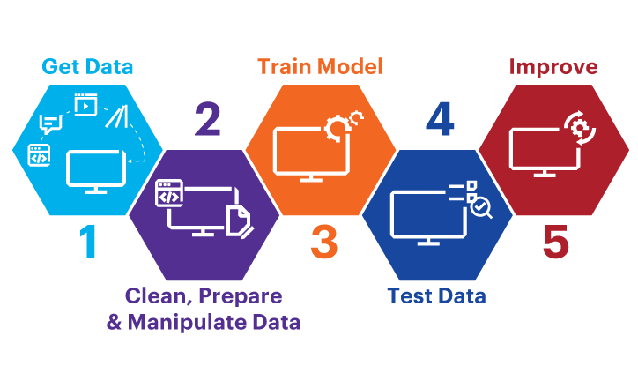

**In a nutshell, the contributions of this research are listed as follows:**

Our first contribution is to train several machine learning algorithms using four different clinical datasets for detecting diabetes. All the datasets are pre-processed by applying different pre-processing techniques.

Secondly, the performances of each ML algorithms with four datasets are analyzed with respect to several parameters like precision, Recall, f1-score, ROC curve and accuracy. Further, we have identified several important features or attributes using different feature selection methods such as correlation, chi-square, etc. The feature selection methods find out the mostly correlated features to diabetes disease. The performances of the ML algorithms were also analyzed on the reduced set of attributes.

Thirdly, based on the performance results, web-based application is developed to predict the diabetes of individuals.

## DATASET

The Pima Indian dataset is an open‐source dataset that is publicly available for machine learning classification, which has been used in this work along with a private dataset. It contains 768 patients’ data, and 268 of them have developed diabetes.Figure shows the ratio of people having diabetes in the Pima Indian dataset.Table demonstrates the eight features of the open‐source Piman Indian dataset RTML private dataset: A significant contribution of this work is to present a private dataset from Rownak Textile Mills Ltd, Dhaka, Bangladesh, referred to as RTML, to the scientific community. Following a brief explanation of the study to the female volunteers, they voluntarily agreed to participate in the study. This dataset comprises six features, that is, pregnancy, glucose, blood pressure, skin thickness, BMI, age, and outcome of diabetes from 203 female individuals aged between 18 and 77. In this work, blood glucose was measured by the GlucoLeader Enhance blood sugar meter. The blood pressure and skin thickness of the participants were obtained by OMRON HEM‐7156T and digital LCD body fat caliper machines, respectively

* **Pregnancies** :- Number of times a woman has been pregnant
* **Glucose** :- Plasma Glucose concentration of 2 hours in an oral glucose tolerance test
* **BloodPressure** :- Diastollic Blood Pressure (mm hg)
* **SkinThickness** :- Triceps skin fold thickness(mm)
* **Insulin** :- 2 hour serum insulin(mu U/ml)
* **BMI** :- Body Mass Index ((weight in kg/height in m)^2)
* **Age** :- Age(years)
* **DiabetesPedigreeFunction** :-scores likelihood of diabetes based on family history)
* **Outcome** :- 0(doesn't have diabetes) or 1 (has diabetes)

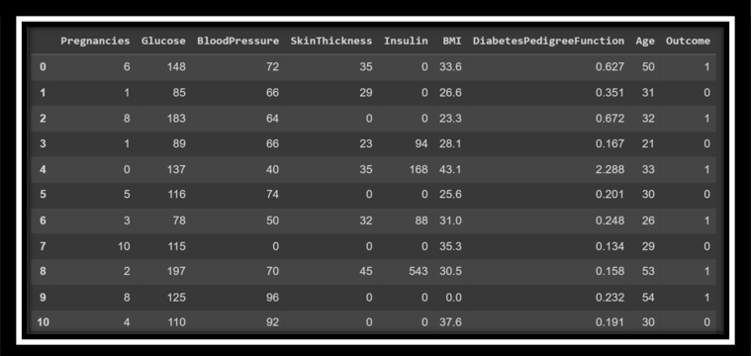

Table 1-DIABETES PREDICTION DATA

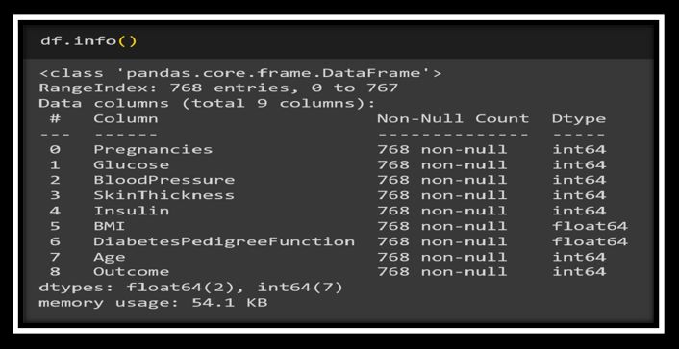

Table -2-DIABETES PREDICTION

Fig-1-Pair plot for finding the relationship between features for diabetes prediction

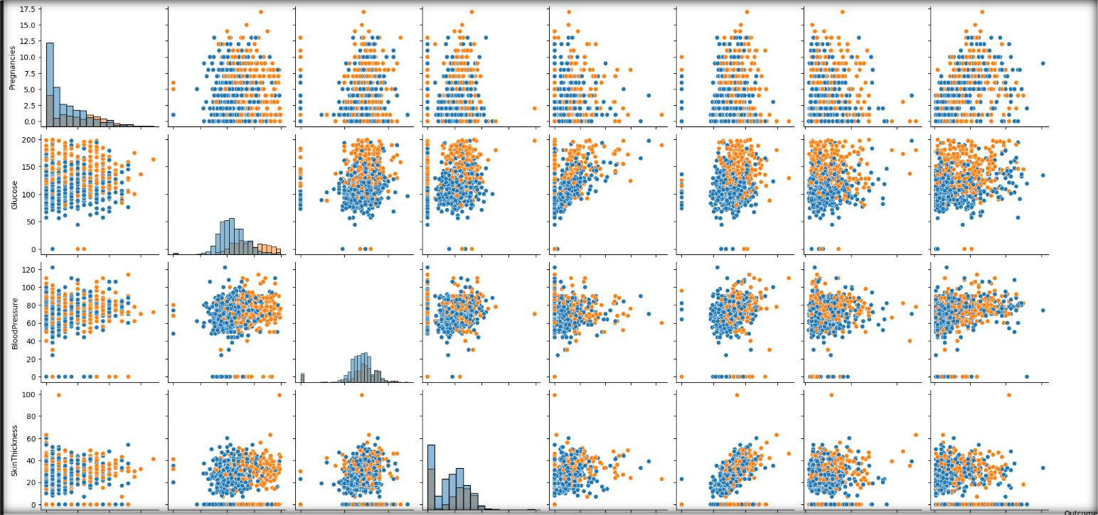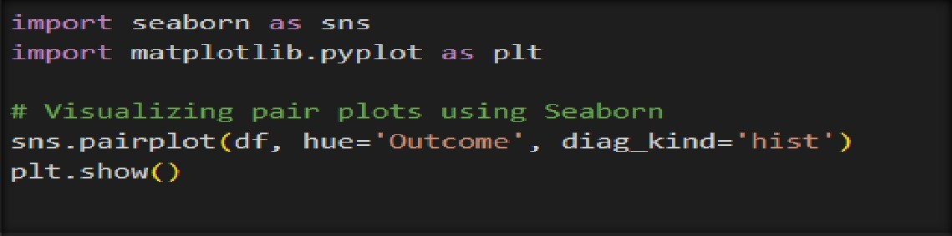

## DATASET PREPROCESSING

In the merged dataset, we discovered a few exceptional zero values. For example, skin thickness and Body Mass Index (BMI) cannot be zero. The zero value has been replaced by its corresponding mean value. The training and test dataset has been separated using the holdout validation technique, where 80% is the training data and20% is the test data. Mutual Information: Mutual information attempts to measure the interdependence of variables. It produces information gain, and its higher values indicate greater dependency the mutual information of various features, that is, the importance of each attribute of this dataset. For example, according to this figure, the diabetes pedigree function seems less important according to this mutual information technique.

An extensive investigation has been performed while choosing the best‐performed regressor technique to predict the insulin feature of the RTML dataset from the Pima Indian dataset. As the actual value of the insulin was not available in the RTML dataset, the Pima Indian dataset was initially used to select the best regression model. First, the Pima Indian dataset was divided into an 8:2 ratio and three supervised regression models, extreme gradient boosting technique (XGB), support vector regression (SVR), and Gaussian process regression (GPR), have been employed to predict the selected outcome, that is, insulin of the validation samples of the Pima Indian dataset.

### DATA CLEANING :

* Dropping duplicate values
* Checking NULL values

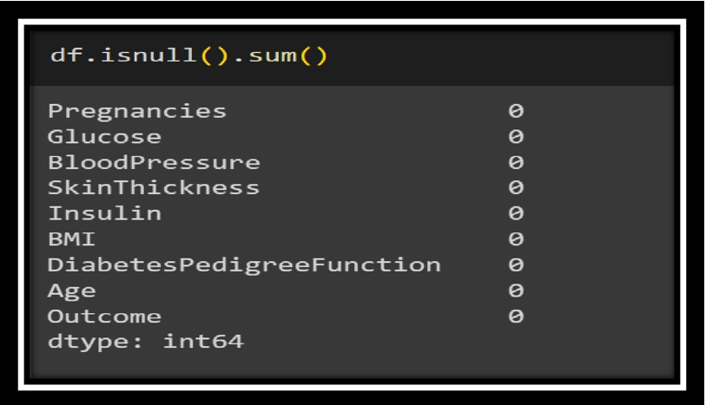

* Figure-2-Checking NULL values

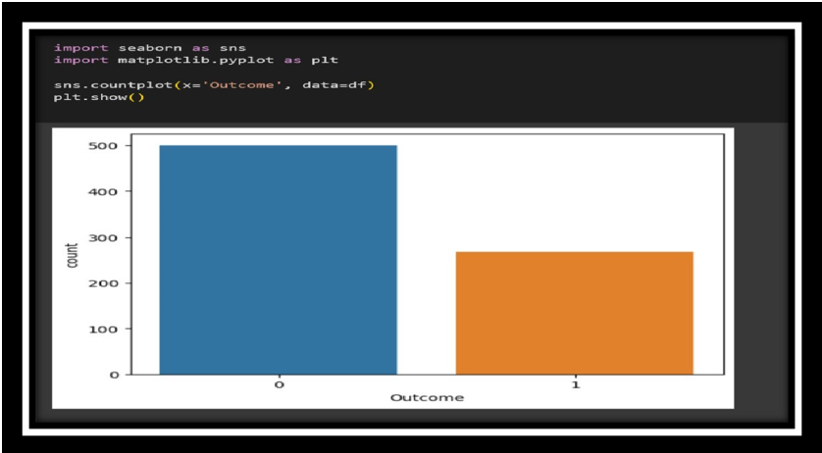

Fig-3-PLoting the data using count plot

**Conclusion :- We observe that number of people who do not have diabetes is far more than people who do which indicates that our data is imbalanced**

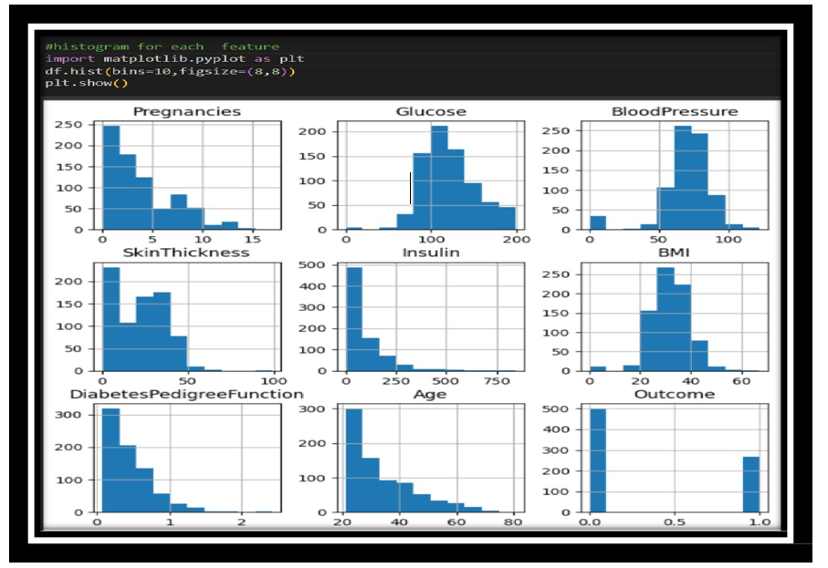Figure-4-Distribution of data using histogram

**Conclusion :- We observe that only glucose and Blood Pressure are normally distributed rest others are skewed and have outliers**

## FEATURE SELECTION

**Pearson's Correlation Coefficient :**

Helps you find out the relationship between two quantities. It gives you the measure of the strength of association between two variables. The value of Pearson's Correlation Coefficient can be between -1 to +1. 1 means that they are highly correlated and 0 means no correlation. A heat map is a two-dimensional representation of information with the help of colors. Heat maps can help the user visualize simple or complex information.

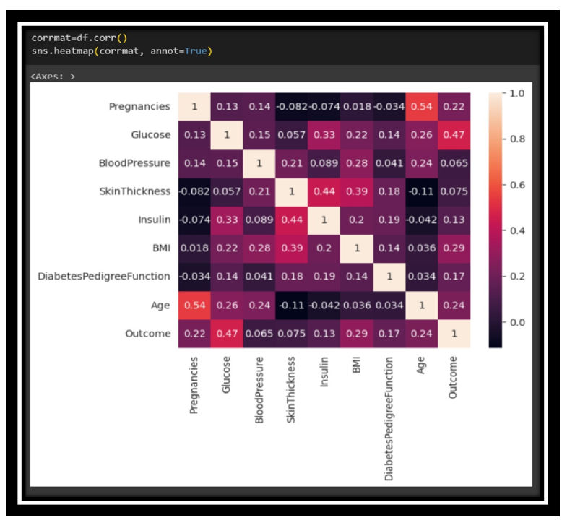

Fig-5-Ploting the Confusion matrix for diabetes data

**CONCLUSION :- Observe the last row 'Outcome' and note its correlation scores with different features. We can observe that Glucose, BMI and Age are the most correlated with Outcome. Blood Pressure, Insulin, Diabetes Pedigree Function are the least correlated, hence they don't contribute much to the model so we can drop them. Read more about this her**

# HANDLING OUTLIERS

Handling outliers is an important step in data preprocessing to ensure that they do not unduly influence the results of statistical analyses or machine learning models. Outliers are data points that significantly differ from the rest of the data and may skew the analysis. Here are some common techniques for handling outliers:

**Identifying Outliers:**

Visual inspection: Use box plots, scatter plots, or histograms to visually identify data points that fall far from the main cluster.

Statistical methods: Calculate z-scores or interquartile ranges (IQR) to identify values that deviate significantly from the mean or median.

**Removing Outliers:**

One simple approach is to remove outliers from the dataset. However, this should be done cautiously, as it may lead to information loss.

For extreme cases, a rule of thumb is to remove values beyond a certain multiple of the standard deviation or IQR.

**Transforming Data:**

Transformations like logarithmic, square root, or Box-Cox transformations can sometimes make the distribution more normal and reduce the impact of outliers.

**Winsorizing:**

Winsorizing involves capping extreme values by replacing them with less extreme values (e.g., replacing values above a certain threshold with the maximum acceptable value).

**Imputing:**

Instead of removing outliers, you can impute them by replacing extreme values with the mean, median, or a more suitable value based on the context.

**Model-based Handling:**

Some machine learning models are robust to outliers. Robust models, like Random Forests or Support Vector Machines, may handle outliers better than linear models.

The Quantile Transformer is a method used for transforming features in a way that makes the distribution of values more uniform or normal. This transformation can be helpful in making the data conform more closely to the assumptions of certain statistical models. Here's an explanation of how the Quantile Transformer works and why it can be beneficial:

**How Quantile Transformer Works:**

**Ranking the Data:**

The ranked data is then mapped to a uniform distribution. This means that each data point's rank is transformed into a value between 0 and 1, representing its cumulative distribution function (CDF) in the original distribution.

**Mapping to Desired Distribution:**

The values from the uniform distribution are then mapped to the desired distribution, often a normal distribution. This is typically achieved by applying the inverse of the cumulative distribution function (CDF) of the desired distribution.

Benefits of Quantile Transformer:

**Spread of Most Frequent Values:**

The transformation tends to spread out the most frequent values, making the distribution more uniform. This can be beneficial for certain algorithms that assume a uniform or normal distribution.

**Robustness to Outliers:**

Quantile Transformer is robust to outliers because it does not rely on mean and standard deviation calculations. Outliers are less likely to have a significant impact on the transformation.

**Normalization:**

It helps in normalizing the distribution of each feature, making it suitable for models that assume normally distributed data.

**Equalizes Marginal Distributions:**

The method aims to make the marginal distributions of each feature more similar, which can be useful in situations where equalizing the importance of different features is desired

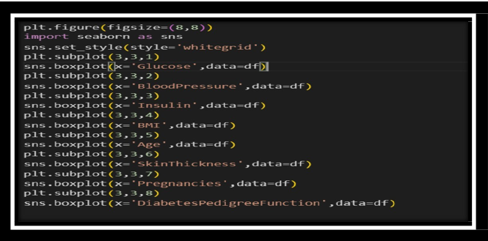

Figure-6-Ploting the subplot

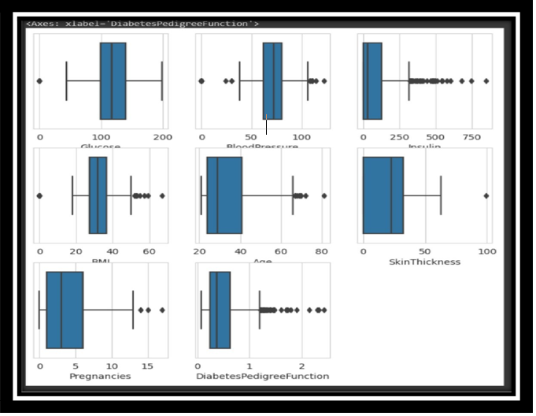

Figure-7-Detecting the outliers

**Outliers are unusual values in your dataset, and they can distort statistical analyses and violate their assumptions. Hence it is of utmost importance to deal with them. In this case removing outliers can cause data loss so we have to deal with it using various scaling and transformation techniques**

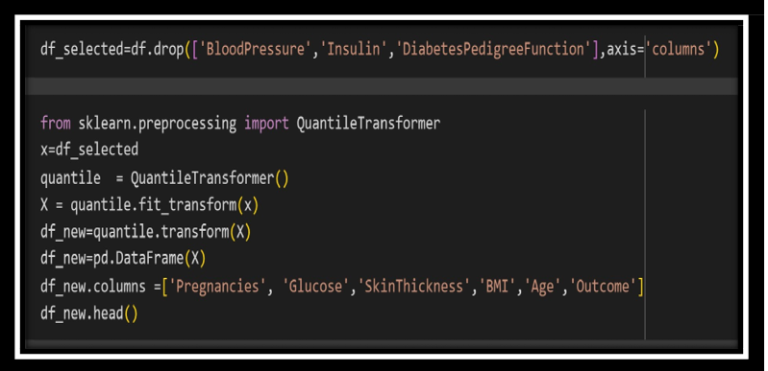

Figure-8-Normalizing the data using QuantileTransform

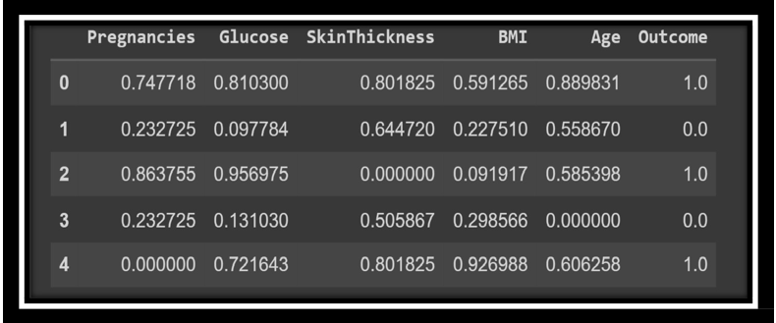

Fig-9-DIABETES PREDICTION

**Quantile Transformer :- This method transforms the features to follow a uniform or a normal distribution. Therefore, for a given feature, this transformation tends to spread out the most frequent values. It also reduces the impact of (marginal) outliers: this is therefore a robust preprocessing scheme.**

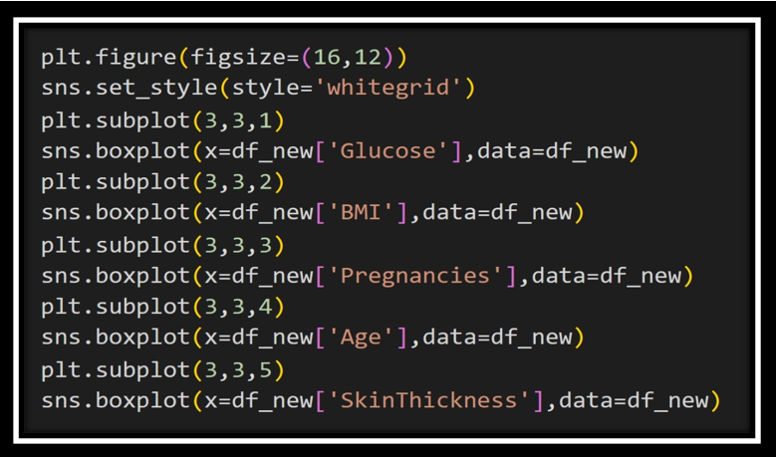

Fig-10-Ploting the diabetes data

## PACKAGES USED

##### import pandas as pd

Pandas are an open source, BSD- licensed library providing high – performance, easy- to-use data structures and data analysis tools for thepython programming language

##### PIP

PIP is a package management system used to install and manage software packages written in Python. Many Packages can be found in the default source for packages and their dependencies –Python packageindex (PyPi) pip is a recursive acronym that can stand for either “Pip installs Packages “ or “Pip installs Python”.

##### import numpy as np

Numpy is the core library for scientific computing in python. It providesperformance multidimensional array object, and tools for working with these arrays. If you are already familiar with MATLAB, you might find the tutorial useful to get started with Numpy.

##### import plotly.express as px

Plotly Express is a powerful Python package that provides a high- level interface for creating interactive visualizations. It is built on top of Plotly, a popular open-source library for creating interactive and customizable plots. Plotly Express simplifies the process of creating visually appealing and interactive charts, making it easier for users to explore and communicate their data effectively.

##### from sklearn.model_selection import train_test_split

is a popular machine learning library in Python that provides a wide range of tools for data preprocessing, feature extraction, model selection, and evaluation. It is built on top of NumPy, SciPy, and matplotlib, and offers a consistent interface for working with various machine learning algorithms. The model selection module within scikit-learn provides functions to split data into training and testing subsets, which is crucial for evaluating the performance of machine learning models.

**The train_test_split** function from sklearn.model_selection is used to randomly divide a dataset into training and testing sets. It takes as input the features and labels (or target variable) of the dataset and returns separate subsets for training and testing. This function is commonly used to assess the generalization capabilities of a model by training it on the training set and evaluating its performance on the testing set.

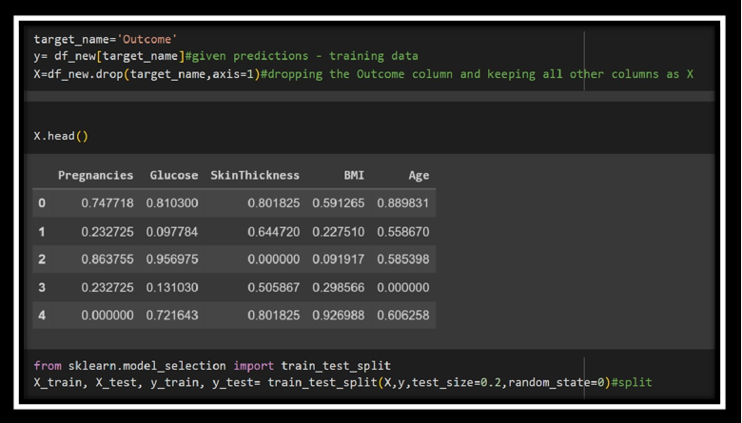

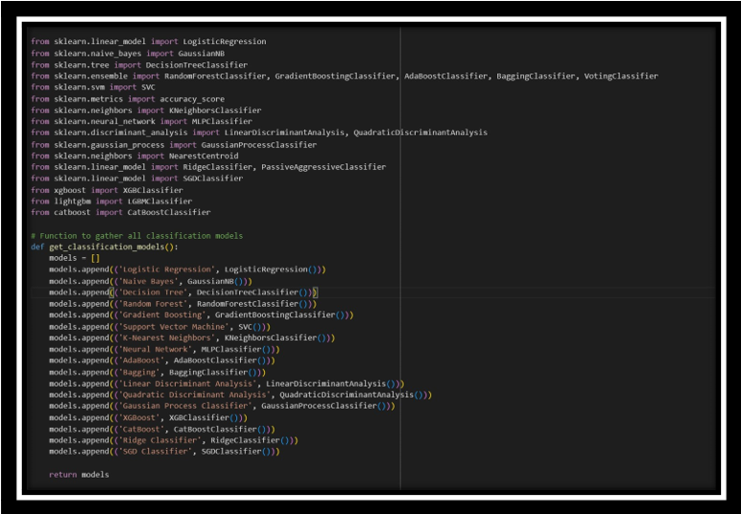Figure-11-DIABETES PREDICTION

Fig-12-Defining all the Classification Alogorithm

**ALGORITHM**

* **Logistic Regression (LogisticRegression):**

**Type: Linear model for classification.**

**Usage: Well-suited for binary classification problems.**

* **Naive Bayes (GaussianNB):**

**Type: Probabilistic model based on Bayes' theorem.**

**Usage: Particularly effective for text classification problems.**

* **Decision Tree (DecisionTreeClassifier):**

**Type: Tree-based model for classification.**

**Usage: Creates a tree structure to make decisions based on features.**

* **Random Forest (RandomForestClassifier):**

**Type: Ensemble learning method based on decision trees.**

**Usage: Builds multiple decision trees and merges their predictions.**

* **Gradient Boosting (GradientBoostingClassifier):**

**Type: Ensemble learning method using boosting.**

**Usage: Builds trees sequentially, each correcting errors of the previous one.**

* **Ensemble Voting Classifier (VotingClassifier):**

**Type: Combines multiple classifiers' predictions.**

**Usage: Allows combining different models for a collective decision.**

* **Support Vector Machine (SVC):**

**Type: Linear or non-linear classification.**

**Usage: Effective in high-dimensional spaces, especially for binary classification.**

* **K-Nearest Neighbors (KNeighborsClassifier):**

**Type: Instance-based learning.**

**Usage: Classifies based on the majority class among its k-nearest neighbors**

* **XGBoost (XGBClassifier):**

**Type: Gradient boosting library.\**

**Usage: Highly efficient and widely used for structured/tabular data.**

* **Bagging (BaggingClassifier):**

**Type: Ensemble learning method using bootstrapped samples.**

**Usage: Trains multiple instances of a model on different subsets**

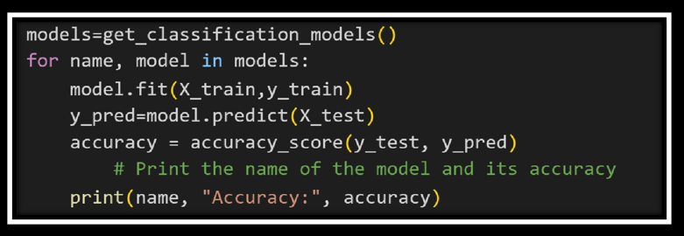

Fig-13-Fitting the model for all the hybrid models defined

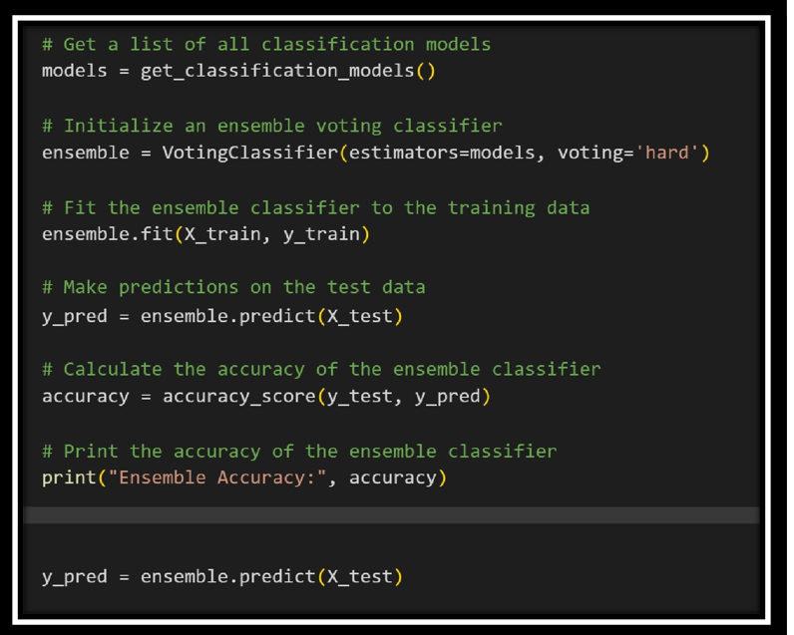

Fig-14-Making predictions for the training data

#### EXPERIMENTAL RESULTS ANALYSIS

Our proposed model is tested and evaluated in this section using a variety of machine learning algorithms, including Naïve Bayes, Decision Trees, Random Forest, Support Vector Machine, Logistic Regression, Ensemble Learning (Voting Classifier) and K-NN. To find the effectiveness and each of them contains different types and number of attributes.

|  |  |
| --- | --- |
| **ALGORITHM** | **ACCURACY** |
| **Logistic Regression** | **81.02%** |
| **Naive Bayes** | **75.73%** |
| **Decision Tree** | **73.37%** |
| **Random Forest** | **81.07%** |
| **KNN Classifier** | **75.97%** |
| **Support Vector Machine** | **79.22%** |
| **Voting Classifier** | **81.16%** |
| **Neural Network** | **77.27%** |
| **Bagging** | **79.75%** |
| **XGBoost** | **74.77%** |
| **AdaBoost** | **75.23%** |

Table-3-Accuracy of all the models for Diabetes prediction

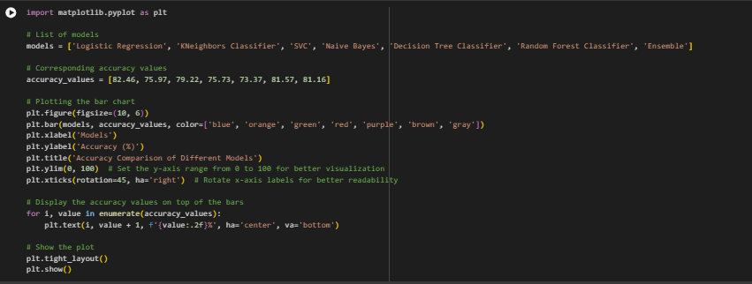

Figure-15-DIABETES PREDICTION

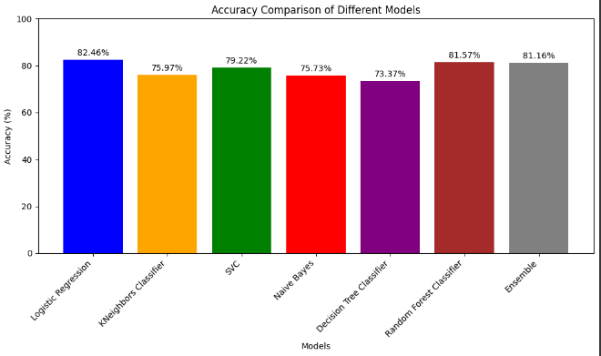

Figure-16-Comparision of Accuracy and Precision for different modes

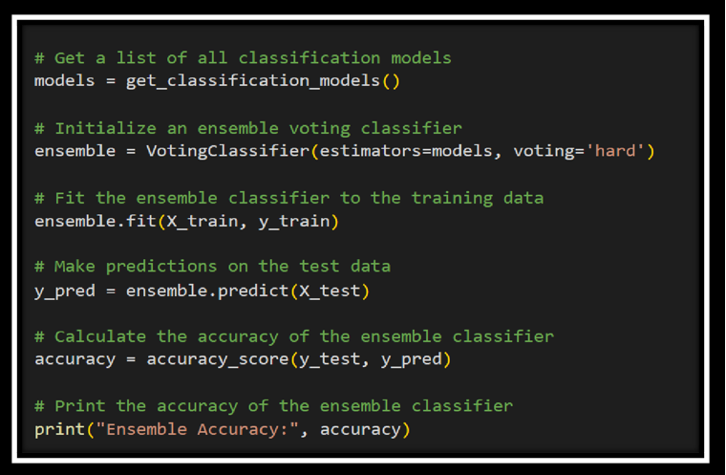

Fig-17-Fiiting the model using ensemble

|  |  |
| --- | --- |
| **ENSEMBLE ACCURACY**  **FOR DIABETES PREDICTION** | **81.16%** |

Table-4-Ensemble Accuracy for Diabetes prediction

## PERFORMANCE EVALUATION

## 

## 

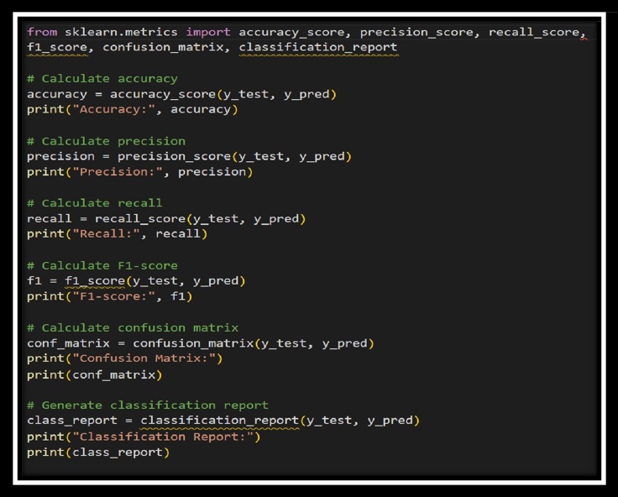

Fig-18-DIABETES PREDICTION

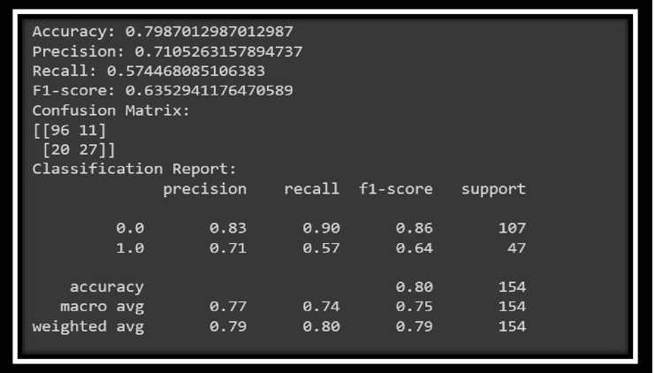

Fig-19-Classificaton Report for Diabetes Prediction

## CONFUSION MATRIX

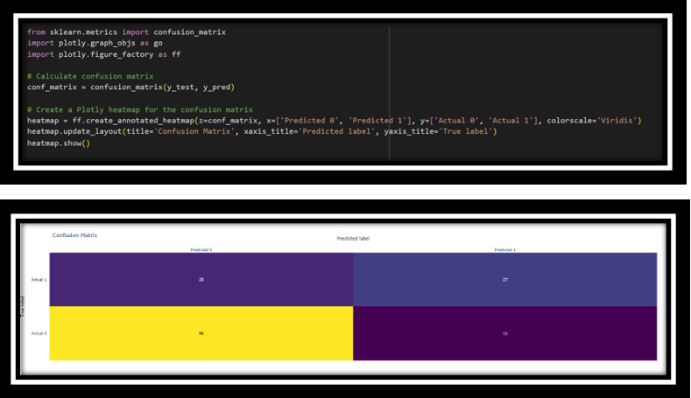

Fig-20-Confusion matrix of predicted data for diabetes prediction

**HEART DISEASE PREDICTION USING MACHINE LEARNING**

**SYSTEM DESIGN**

The first requirement of the model is the dataset, once we have collected the dataset preprocessing of the data comes into play, preprocessing includes omission of duplicate entries, handling missing entries etc. After that in this proposed model normalization of the data has been done and then training and testing data is formed out of the dataset, that is to use the training set for model training and use the testing set to test the proposed model that is the trained model. This splitting has been performed randomly in a complete dataset. After that we applied many techniques/classifiers on the training data set and train the model, classifier includes Linear Regression, K-nearest Neighbor, Decision Trees, Support Vector Machine, Gaussian Naive Bayes, and then an average of all these predictions made to get the result of average Ensemble Learning

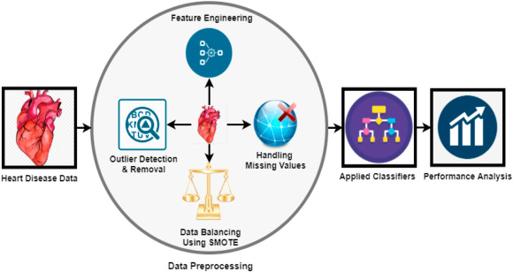

Another Ensemble method is also applied in this paper that includes Random Forest that is Bagging Ensemble Method and extreme Gradient Boosting that is Boosting Ensemble learning method to get the prediction results. At last evaluation of techniques has been done with the testing dataset. And the result of all these classifiers has been evaluated, these results include - Accuracy, Recall, F-1 Score, Precision, ROC - AUC score along with AUC curves. Analyzing and Comparing all these methods has been done to get the best technique/method on this dataset and preprocessing methods.

## DATASET

The dataset comprises various features related to individuals' health, with a focus on factors associated with heart disease diagnosis. These features include demographic information such as age and gender, as well as physiological indicators like resting blood pressure, serum cholesterol levels, and the maximum heart rate achieved during stress testing. Additionally, the dataset includes categorical variables such as chest pain type, fasting blood sugar levels, and electrocardiographic results. Factors related to exercise, such as the presence of exercise- induced angina, ST depression, and the slope of the peak exercise ST segment, are also considered. Moreover, the dataset incorporates information about the number of major vessels colored by fluoroscopy and the presence of thalassemia. The ultimate target variable, represented by 'target,' signifies whether an individual has heart disease (1) or not (0). This comprehensive set of features provides a valuable basis for developing predictive models aimed at identifying individuals at risk of heart disease based on their health characteristics.

**The dataset contains the following features:**

1. **age(in years)**
2. **sex:** (1 = male; 0 = female)
3. **cp:** chest pain type
4. **trestbps:** resting blood pressure (in mm Hg on admission to the hospital)
5. **chol:** serum cholestoral in mg/dl
6. **fbs:** (fasting blood sugar > 120 mg/dl) (1 = true; 0 = false)
7. **restecg:** resting electrocardiographic results
8. **thalach:** maximum heart rate achieved
9. **exang:** exercise induced angina (1 = yes; 0 = no)
10. **oldpeak**: ST depression induced by exercise relative to rest
11. **slope:** the slope of the peak exercise ST segment
12. **ca:** number of major vessels (0-3) colored by flourosopy
13. **thal:** 3 = normal; 6 = fixed defect; 7 = reversable defect
14. **target:** 1 or 0

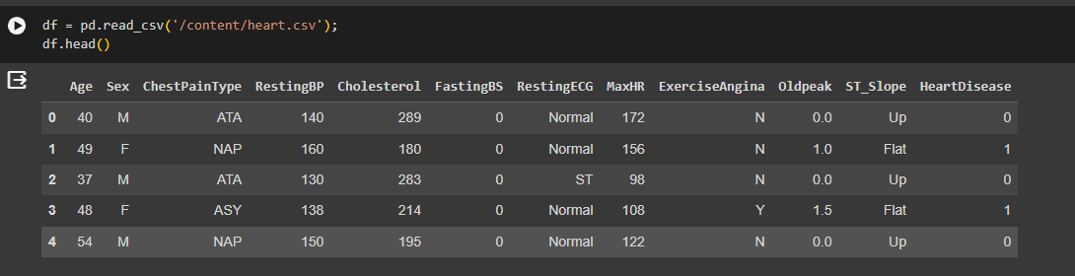

Table-5-HEART DISEASE PREDICTION-DATA

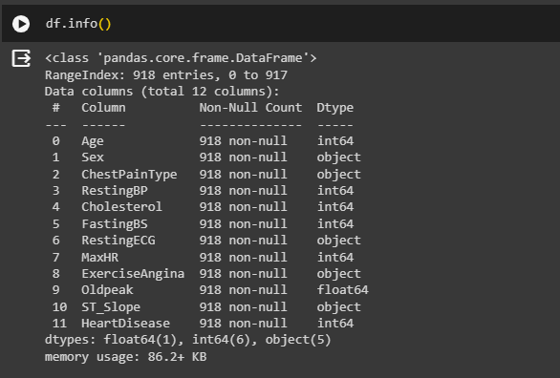

Fig -21-HEART DISEASE PREDICTION

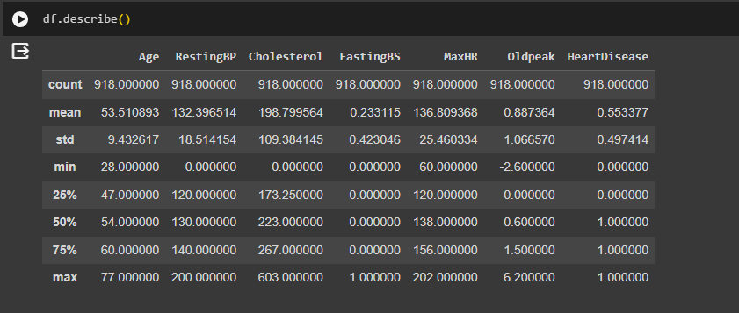

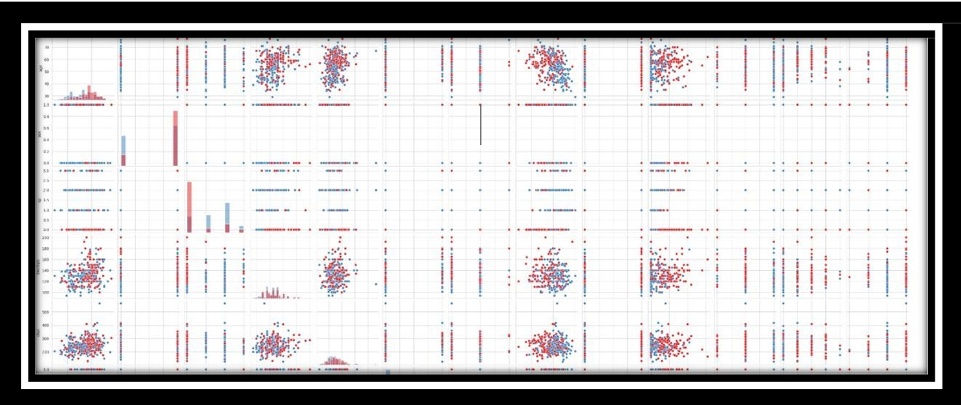Table-6-Statistical Summary of heart disease data

Fig -23-Pair plot for heart disease data(relationship between the data)

This pair plot provides a visual representation of the relationships between different pairs of features, with distinct markers for individuals with and without heart disease. Patterns and separations between the classes can offer insights into the potential predictive power of certain features for heart disease

##### DATASET PREPROCESSING

##### Handling Missing Data: Check and address any missing values in the dataset. Depending on the extent of missingness, consider imputation or removal of affected instances or features.

##### Categorical Encoding: Convert categorical variables (e.g., 'sex,' 'cp,' 'fbs,' 'restecg,' 'exang,' 'slope,' 'thal') into numerical representations using techniques like one-hot encoding to ensure compatibility with machine learning algorithms.

##### Feature Scaling: Normalize numerical features (e.g., 'age,' 'trestbps,' 'chol,' 'thalach,' 'oldpeak') to a consistent scale, such as standardization, to prevent certain features from dominating others.

##### Outlier Detection and Handling: Identify and manage outliers that could adversely affect model performance. This may involve transforming or removing extreme values.

##### Correlation Analysis: Explore correlations between features to identify potential multicollinearity, and consider excluding highly correlated variables to enhance model interpretability and stability.

##### Balancing the Dataset: Evaluate and address any class imbalance in the 'target' variable to ensure that the model does not skew towards the majority class.

##### Train-Test Split: Divide the dataset into training and testing sets to assess model performance on unseen data. Feature Selection: Depending on the dataset's size and complexity, consider feature selection techniques to choose the most relevant features for prediction, improving model efficiency.

##### Data Exploration: Visualize and explore the distribution of features, relationships between variables, and the prevalence of heart disease cases to gain insights into the dataset's characteristics.

##### Handling Categorical Variables (if needed): If the model chosen requires numerical input, transform categorical variables (e.g., 'thal') into a suitable format using techniques like label encoding or creating ordinal mappings

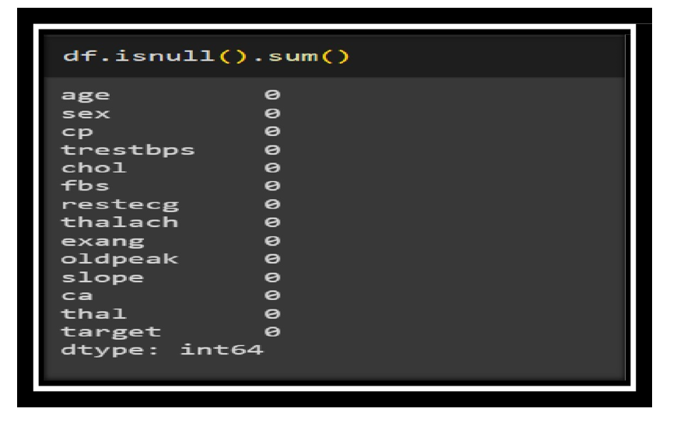

Fig-24-Finding the missing values

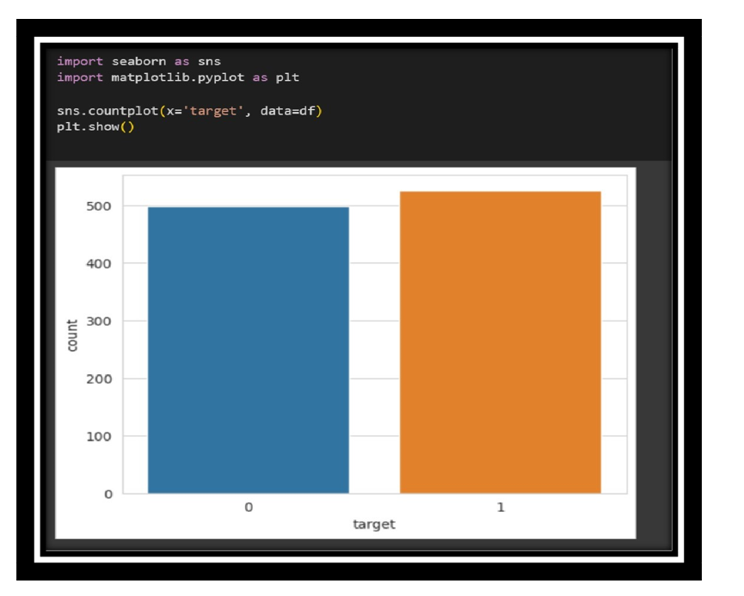

Fig-25-Count plot of given heat disease data

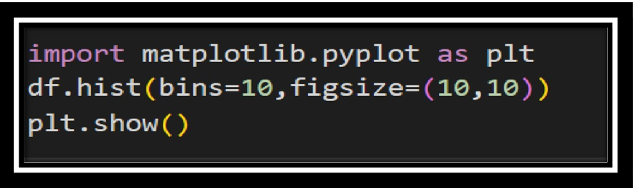

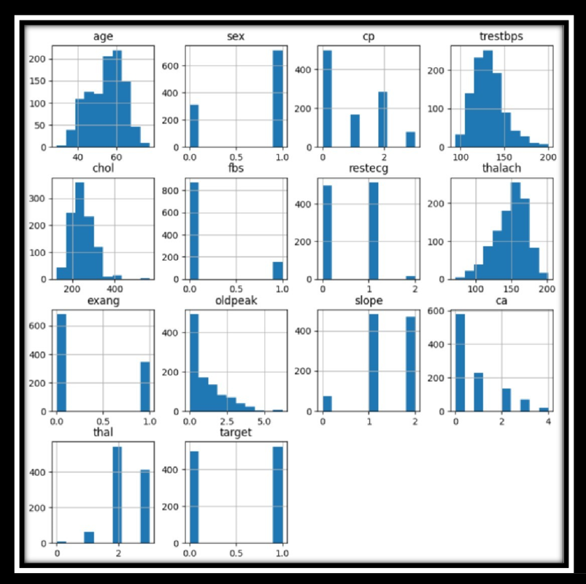

Fig -26-Distribution of the data using histogran

## FEATURE SELECTION

**Pearson's Correlation Coefficient :**

Helps you find out the relationship between two quantities. It gives you the measure of the strength of association between two variables. The value of Pearson's Correlation Coefficient can be between -1 to +1. 1 means that they are highly correlated and 0 means no correlation. A heat map is a two-dimensional representation of information with the help of colors. Heat maps can help the user visualize simple or complex information.

Pearson's Correlation Coefficient is a statistical measure that quantifies the strength and direction of a linear relationship between two continuous variables. It produces a value between -1 and +1, where -1 indicates a perfect negative linear relationship, 1 indicates a perfect positive linear relationship, and 0 signifies no linear correlation. In the context of feature selection, Pearson's correlation coefficient can be utilized to identify and assess the degree of correlation between different features in a dataset. High correlations between features may indicate redundancy, and selecting only one of them can reduce dimensionality without losing significant information. A heatmap is a graphical representation often employed to visualize correlation matrices, where colors represent the strength and direction of correlations. Darker colors, such as deep blue or deep red, signify stronger correlations, providing an intuitive and visual way to identify relationships among variables. When using Pearson's Correlation Coefficient and heatmaps for feature selection, it's common to set a correlation threshold beyond which features are considered highly correlated and potentially candidates for removal to enhance model interpretability and performance

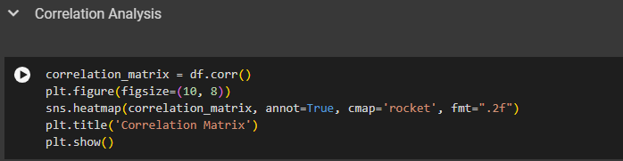

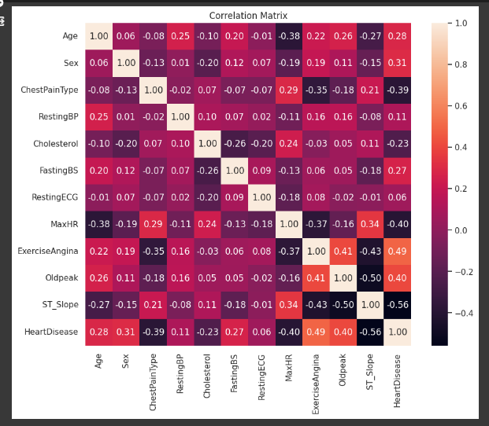

Fig -27-Correlation of Heart disease data

**CONCLUSION :- Observe the last row 'Outcome' and note its correlation scores with different features. We can observe that Glucose, BMI and Age are the most correlated with Outcome. BloodPressure, Insulin, DiabetesPedigreeFunction are the least correlated, hence they don't contribute much to the model so we can drop them. Read more about this her**

# HANDLING OUTLIERS :

Handling outliers is an important step in data preprocessing to ensure that they do not unduly influence the results of statistical analyses or machine learning models. Outliers are data points that significantly differ from the rest of the data and may skew the analysis. Here are some common techniques for handling outliers.

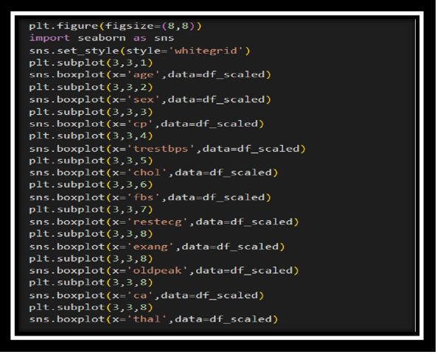

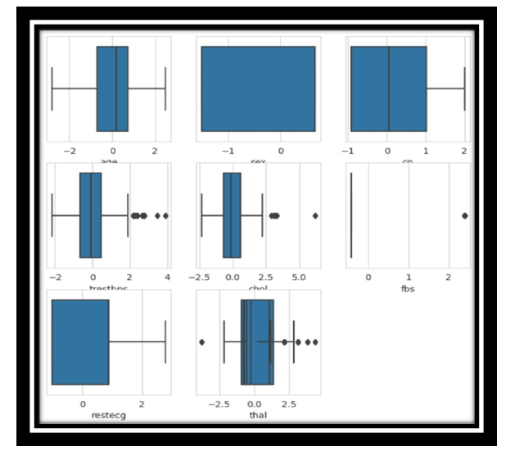

Figure -28-Decting the Outliers

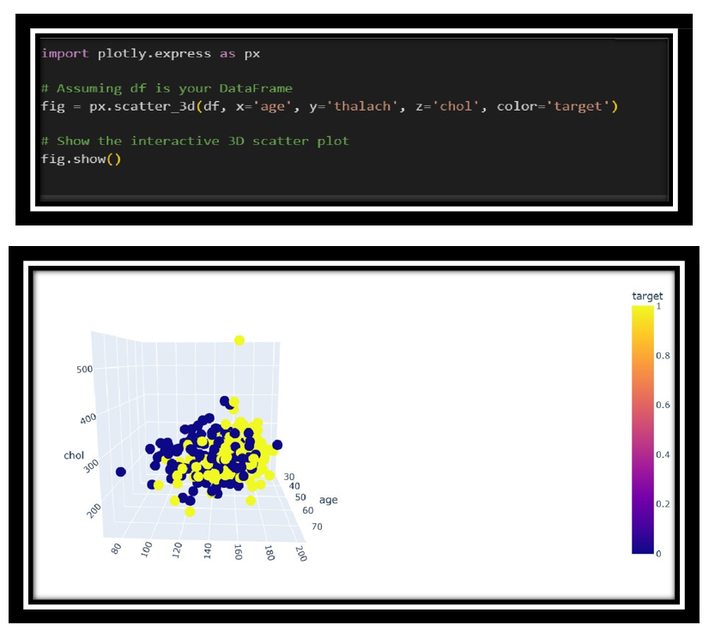

Figure -29-Interactive 3D scatter plot

Figure -30-Interactive 3D scatter plot for the given data

**PACKAGES USED IN HEART DISEASE PREDICTION**

##### import pandas as pd

Pandas are an open source, BSD- licensed library providing high – performance, easy- to-use data structures and data analysis tools for thepython programming language

##### PIP

PIP is a package management system used to install and manage software packages written in Python. Many Packages can be found in the default source for packages and their dependencies –Python packageindex (PyPi) pip is a recursive acronym that can stand for either “Pip installs Packages “ or “Pip installs Python”.

##### import numpy as np

Numpy is the core library for scientific computing in python. It providesperformance multidimensional array object, and tools for working with these arrays. If you are already familiar with MATLAB, you might find the tutorial useful to get started with Numpy.

##### import plotly.express as px

Plotly Express is a powerful Python package that provides a high- level interface for creating interactive visualizations. It is built on top of Plotly, a popular open-source library for creating interactive and customizable plots. Plotly Express simplifies the process of creating visually appealing and interactive charts, making it easier for users to explore and communicate their data effectively.

##### from sklearn.model_selection import train_test_split

is a popular machine learning library in Python that provides a wide range of tools for data preprocessing, feature extraction, model selection, and evaluation. It is built on top of NumPy, SciPy, and matplotlib, and offers a consistent interface for working with various machine learning algorithms. The model selection module within scikit-learn provides functions to split data into training and testing subsets, which is crucial for evaluating the performance of machine learning models.

The train_test_split function from sklearn.model_selection is used to randomly divide a dataset into training and testing sets. It takes as input the features and labels (or target variable) of the dataset and returns separate subsets for training and testing. This function is commonly used to assess the generalization capabilities of a model by training it on the training set and evaluating its performance on the testing set.

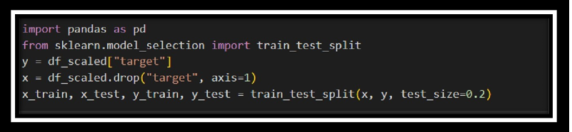

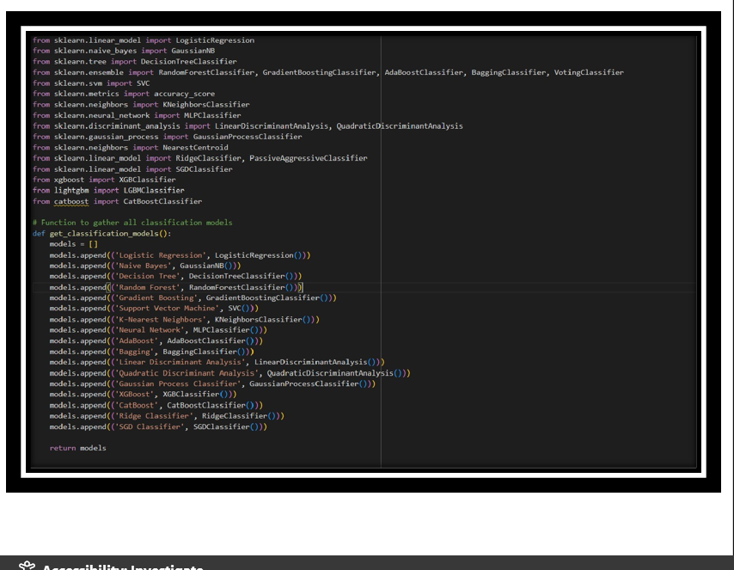

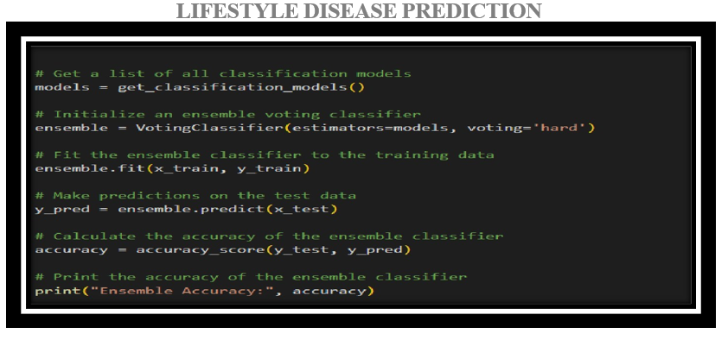

Table-7-Evaluation Metrics for all the Hybrid Models

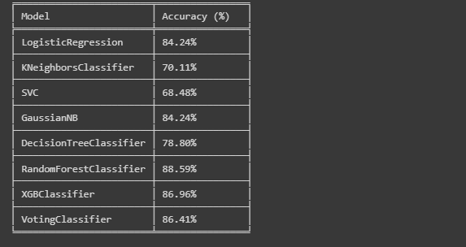

|  |  |
| --- | --- |
| **ALGORITHM** | **ACCURACY** |
| **Logistic Regression** | **84.24%** |
| **Naive Bayes** | **84.24%** |
| **Decision Tree** | **78.80%** |
| **Random Forest** | **89.59%** |
| **Support Vector Machine** | **68.48%** |
| **K-Nearest Neighbors** | **70.11%** |
| **XGB Classifier** | **86.86%** |
| **Voting Classifier** | **86.41%** |

Table-8-Accuracy of Hybrid Models

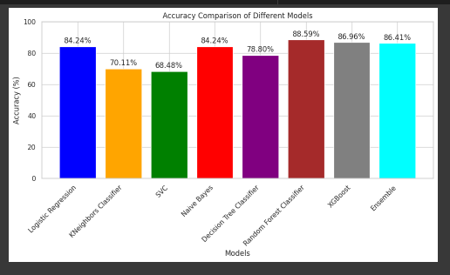

Figure -32-Comparison of Accuracy and Precision for Different Models

## PERFORMANCE EVALUATION

## 

Figure -33-Performance Evaluation of Heart Disease Prediction

|  |  |
| --- | --- |
| **ENSEMBLE ACCURACY**  **FOR HEART DISEASE PREDICTION** | **86.41%** |

Table-9-Ensemble Accuracy of Heart Disease Prediction

**CHRONIC KIDNEY DISEASE PREDICTION USING MACHINE LEARNING**

**SYSTEM DESIGN**

The first requirement of the model is the dataset, once we have collected the dataset preprocessing of the data comes into play, preprocessing includes omission of duplicate entries, handling missing entries etc. After that in this proposed model normalization of the data has been done and then training and testing data is formed out of the dataset, that is to use the training set for model training and use the testing set to test the proposed model that is the trained model. This splitting has been performed randomly in a complete dataset. After that we applied many techniques/classifiers on the training data set and train the model, classifier includes Linear Regression, K-nearest Neighbor, Decision Trees, Support Vector Machine, Gaussian Naive Bayes, and then an average of all these predictions made to get the result of average Ensemble Learning

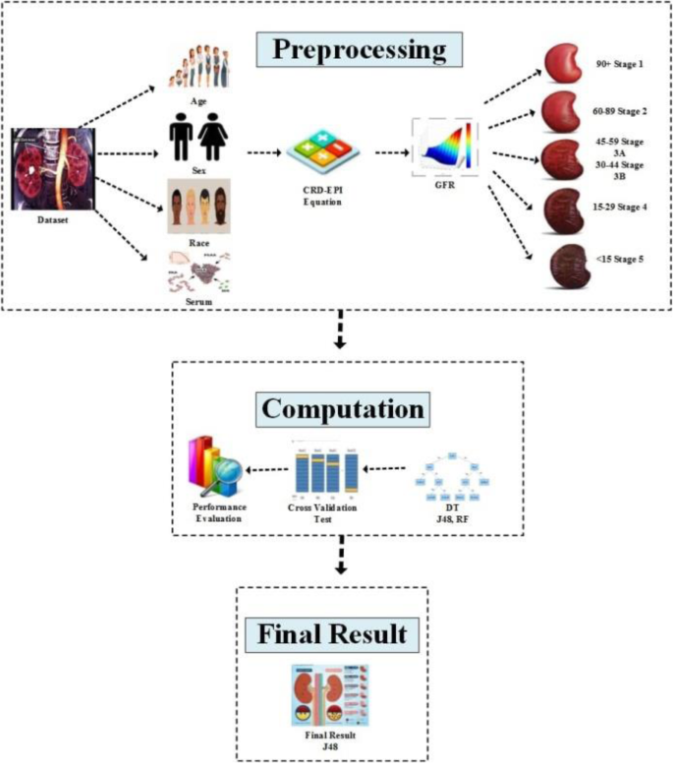

Another Ensemble method is also applied in this paper that includes Random Forest that is Bagging Ensemble Method and extreme Gradient Boosting that is Boosting Ensemble learning method to get the prediction results. At last evaluation of techniques has been done with the testing dataset. And the result of all these classifiers has been evaluated, these results include - Accuracy, Recall, F-1 Score, Precision, ROC - AUC score along with AUC curves. Analyzing and Comparing all these methods has been done to get the best technique/method on this dataset and preprocessing methods.

## DATASET :

The dataset for chronic kidney disease (CKD) encompasses a wide array of medical features aimed at diagnosing and understanding the complexities of renal health. Chronic kidney disease is a prolonged condition leading to renal failure, affecting the kidneys' ability to filter waste and excess fluids from the blood. Symptoms may develop slowly, and diagnosis often involves lab tests. As the disease progresses, symptoms management is crucial, with potential interventions such as dialysis or transplantation in advanced stages. The ultimate target variable, represented by 'target,' signifies whether an individual has chronic kidney disease (1) or not (0). This comprehensive set of features provides a valuable basis for developing predictive models aimed at identifying individuals at risk of chronic kidney disease based on their health characteristics.

**The dataset contains the following features:**

We use 24 medical features + 1 class = 25 ( 11 numeric ,14 nominal)

1.Age(numerical) age in years

2.Blood Pressure(numerical) bp in mm/Hg

3.Specific Gravity(nominal) sg - (1.005,1.010,1.015,1.020,1.025)

4.Albumin(nominal) al - (0,1,2,3,4,5)

5.Sugar(nominal) su - (0,1,2,3,4,5)

6.Red Blood Cells(nominal) rbc - (normal,abnormal)

7.Hemoglobin(numerical) hemo in gms

8.White Blood Cell Count(numerical) wc in cells/cumm

9.Red Blood Cell Count(numerical) rc in millions/cmm

10.Hypertension(nominal) htn - (yes,no)

11.Appetite(nominal) appet - (good,poor)

12.Pedal Edema(nominal) pe - (yes,no)

13.Anemia(nominal) ane - (yes,no)

14.Class (nominal) class - (ckd,notckd)

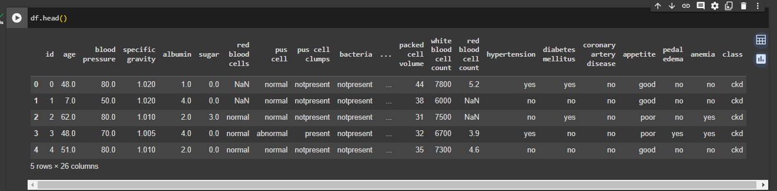

Table-5-HEART DISEASE PREDICTION-DATA

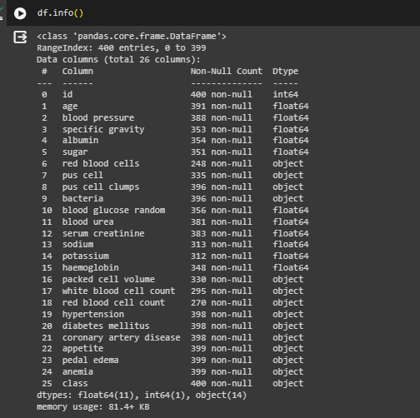

Fig -21-HEART DISEASE PREDICTION

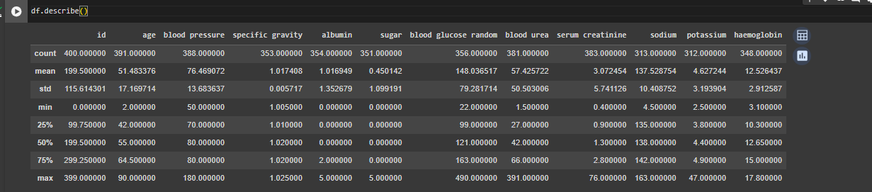

Table-6-Statistical Summary of heart disease data

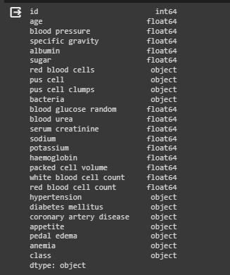

Table : Data types of parameters

##### DATASET PREPROCESSING

##### Handling Missing Data: Check and address any missing values in the dataset. Depending on the extent of missingness, consider imputation or removal of affected instances or features.

##### Categorical Encoding: Convert categorical variables (e.g., 'sex,' 'cp,' 'fbs,' 'restecg,' 'exang,' 'slope,' 'thal') into numerical representations using techniques like one-hot encoding to ensure compatibility with machine learning algorithms.

##### Feature Scaling: Normalize numerical features (e.g., 'age,' 'trestbps,' 'chol,' 'thalach,' 'oldpeak') to a consistent scale, such as standardization, to prevent certain features from dominating others.

##### Outlier Detection and Handling: Identify and manage outliers that could adversely affect model performance. This may involve transforming or removing extreme values.

##### Correlation Analysis: Explore correlations between features to identify potential multi collinearity, and consider excluding highly correlated variables to enhance model interpretability and stability.

##### Balancing the Dataset: Evaluate and address any class imbalance in the 'target' variable to ensure that the model does not skew towards the majority class.

##### Train-Test Split: Divide the dataset into training and testing sets to assess model performance on unseen data. Feature Selection: Depending on the dataset's size and complexity, consider feature selection techniques to choose the most relevant features for prediction, improving model efficiency.

##### Data Exploration: Visualize and explore the distribution of features, relationships between variables, and the prevalence of heart disease cases to gain insights into the dataset's characteristics.

##### Handling Categorical Variables (if needed): If the model chosen requires numerical input, transform categorical variables (e.g., 'thal') into a suitable format using techniques like label encoding or creating ordinal mappings

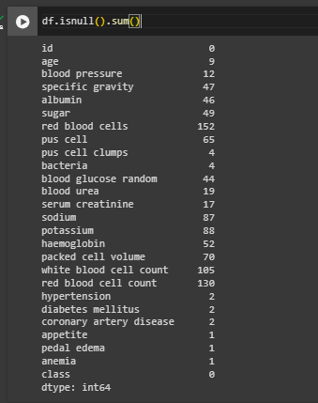

Fig-24-Finding the missing values

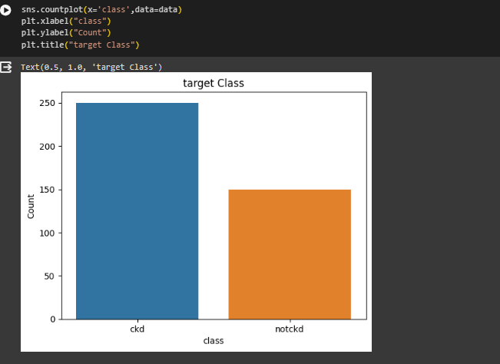

Fig-25-Count plot of given heat disease data

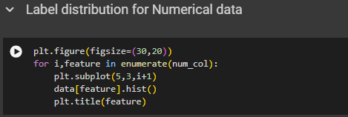

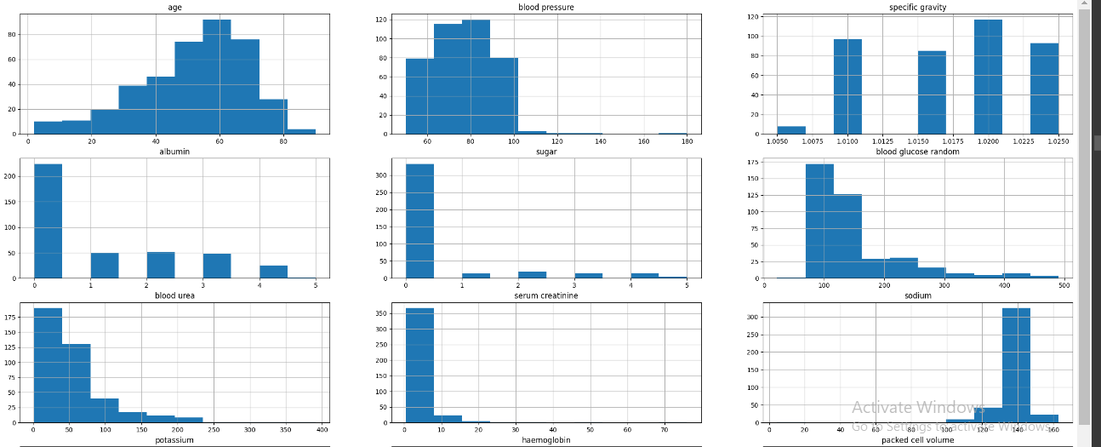

Fig -26-Distribution of the data using histogram

Observations:  
    1.age looks a bit left skewed  
    2.Blood gluscose random is right skewed  
    3.Blood Urea is also a bit right skewed  
    4.Rest of the features are lightly skewed

## FEATURE SELECTION

**Pearson's Correlation Coefficient :**

Helps you find out the relationship between two quantities. It gives you the measure of the strength of association between two variables. The value of Pearson's Correlation Coefficient can be between -1 to +1. 1 means that they are highly correlated and 0 means no correlation. A heat map is a two-dimensional representation of information with the help of colors. Heat maps can help the user visualize simple or complex information.

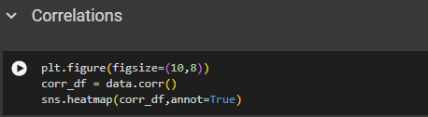

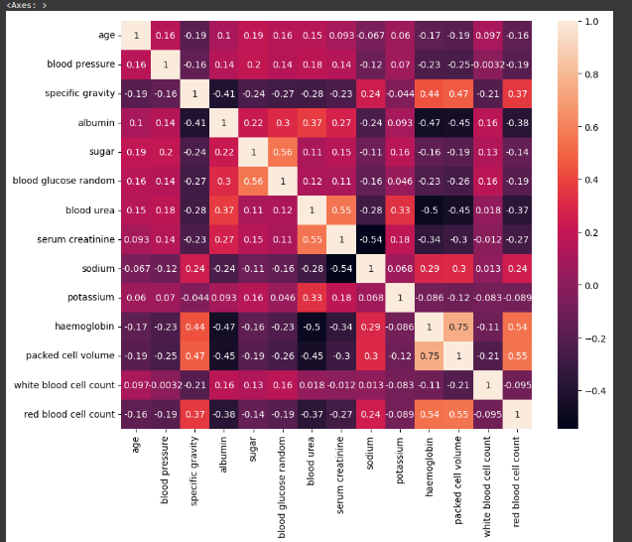

Fig -27-Correlation of CKD data

Positive Correlation:  
Specific gravity -> Red blood cell count, Packed cell volume and Hemoglobin  
Sugar -> Blood glucose random  
Blood Urea -> Serum creatinine  
Hemoglobin -> Red Blood cell count <- packed cell volume  
  
Negative Correlation:  
Albumin, Blood urea -> Red blood cell count, packed cell volume, Hemoglobin  
Serum creatinine -> Sodium

# HANDLING OUTLIERS :

Handling outliers is an important step in data preprocessing to ensure that they do not unduly influence the results of statistical analyses or machine learning models. Outliers are data points that significantly differ from the rest of the data and may skew the analysis. Here are some common techniques for handling outliers:

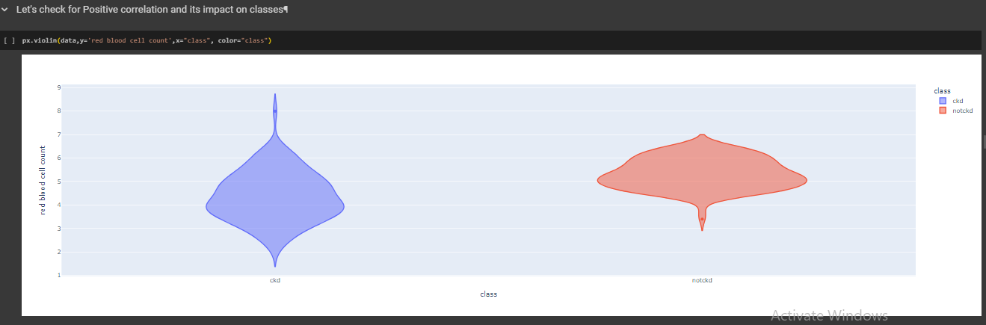

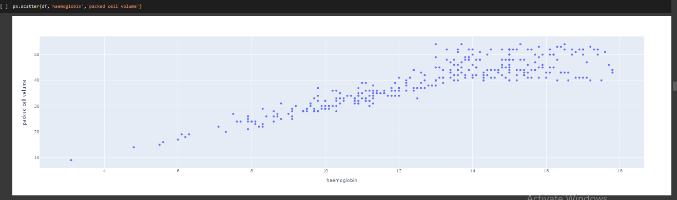

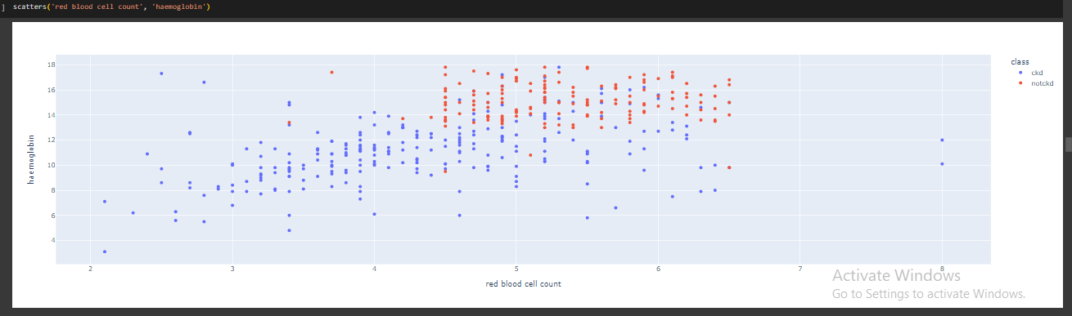

Figure -28-Decting the Outliers

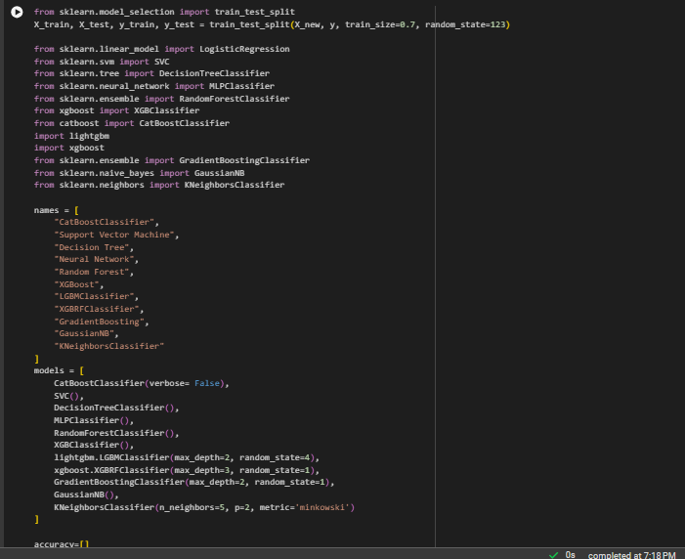

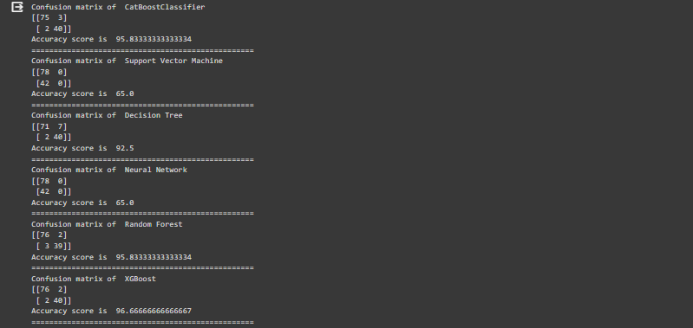

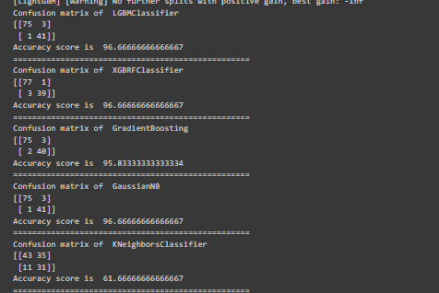

Table-7-Evaluation Metrics for all the Hybrid Models

|  |  |
| --- | --- |
| **ALGORITHM** | **ACCURACY** |
| **Decision Tree** | **91.67%** |
| **Neural Network** | **83.33%** |
| **Support Vector Machine** | **65.00%** |
| **KNN Classifier** | **61.67%** |
| **XGBoost** | **96.67%** |
| **GaussianNB** | **95.67%** |
| **XGBRF Classifier** | **96.67%** |
| **Random Forest Classification** | **95.83%** |

Table-8-Accuracy of Hybrid Models

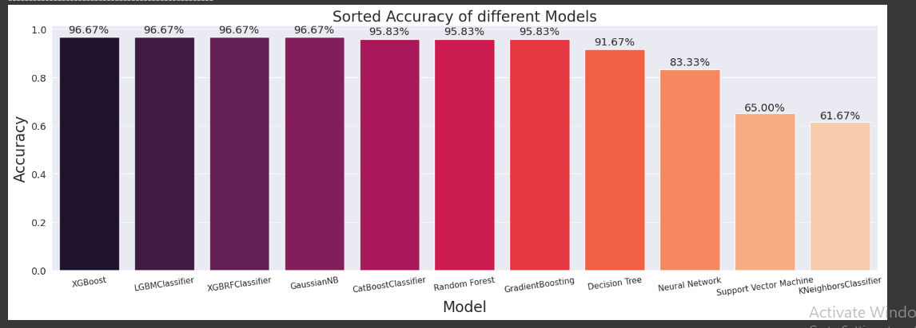

Figure -32-Comparison of Accuracy and Precision for Different Models

## PERFORMANCE EVALUATION

|  |  |
| --- | --- |
| **ACCURACY**  **FOR CKD DISEASE PREDICTION** | **96.67%** |

Table-9-Ensemble Accuracy of Heart Disease Prediction

**PREDICTION USING DEEP LEARNING**

## CNN ARCHITECTURE

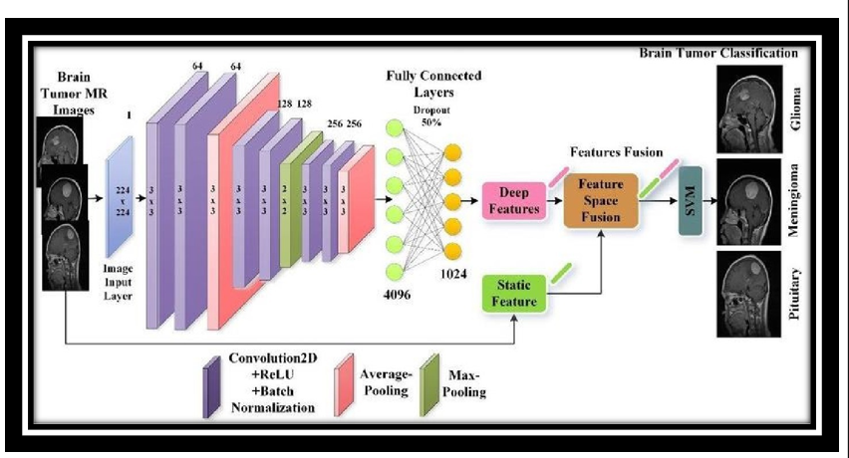

Convolutional Neural Networks (CNNs) are a class of deep neural networks designed for tasks such as image recognition and classification. CNNs are particularly effective in capturing spatial hierarchies of features within images.

The architecture of a CNN is inspired by the visual cortex of the human brain. It consists of multiple layers such as convolutional layers, pooling layers, and fully connected layers. Each layer performs specific operations to extract features from the input data and progressively learn more complex patterns

A Convolutional Neural Network (CNN) is a type of artificial neural network that is particularly effective in image recognition and processing. CNNs are designed to automatically and adaptively learn spatial hierarchies of features from input data. They use a specialized architecture to process data in grid-like structures, such as images.

A Convolutional Neural Network (ConvNet/CNN) is a Deep Learning algorithm that can take in an input image, assign importance (learnable weights and biases) to various aspects/objects in the image, and be able to differentiate one from the other. The pre- processing required in a ConvNet is much lower as compared to other classification algorithms. While in primitive methods filters are hand- engineered, with enough training, ConvNets have the ability to learn these filters/characteristics.

**The key components of a typical CNN architecture include:**

**Input Layer:**

Accepts the raw input data, usually in the form of images.

**Convolutional Layers:**

Convolutional layers are the core building blocks of CNNs. They apply convolutional operations to the input data using filters (also known as kernels).

Convolution helps in detecting patterns, edges, and features by sliding the filters over the input image.

Multiple convolutional layers can be stacked to learn hierarchical features.

**Padding**

Padding in Convolutional Neural Networks (CNNs) is a technique used to address the reduction

in spatial dimensions that occurs when applying convolutional operations. It involves adding extra

pixels (padding) around the input data before applying the convolution operation. Padding is typically added to ensure that the spatial dimensions of the input and output volumes of a convolutional layer remain compatible.

* Preservation of Spatial Information
* Avoiding Border Effects
* Control Over Output Size
* Valid Padding (No Padding)

**Filter**

In Convolutional Neural Networks (CNNs), filters serve as pivotal elements responsible for feature extraction and representation. These filters, also known as convolutional kernels, are small, learnable matrices that traverse the input data, typically images, capturing patterns and local structures. During the convolution operation, each filter scans the input using a sliding window, performing a dot product at each position. The values within the filter matrix are trainable parameters, optimized through the network's training process via backpropagation.

The concept of weight sharing is fundamental to filters in CNNs. As a single filter is applied across the entire input volume, the learned weights are shared, significantly reducing the number of parameters and enhancing the network's ability to generalize patterns across different regions. The size of the filter, often 3x3 or 5x5, is a crucial hyperparameter influencing the receptive field and the complexity of features captured. Moreover, filters are complemented by non-linear activation functions, typically Rectified Linear Units (ReLU), to introduce non-linearity and enable the network to learn intricate relationships within the data

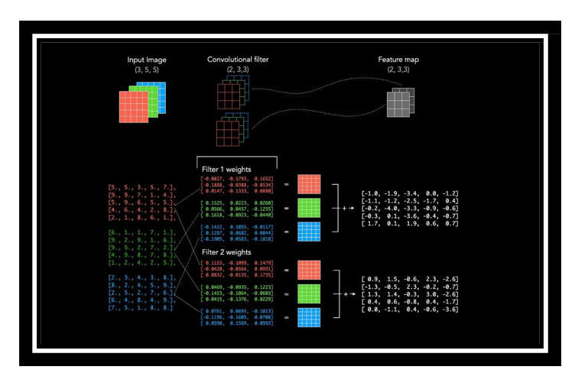

**Activation Function:**

Typically, rectified linear unit (ReLU) activation functions are used after convolutional operations to introduce non-linearity.

ReLU helps the network learn complex patterns and relationships in the data.

**Pooling**

Pooling (Subsampling or Down-sampling) Layers:

Pooling layers reduce the spatial dimensions of the input volume. Common pooling methods include max pooling and average pooling. Pooling helps in reducing computation and controlling over-fitting. The Pooling layer is responsible for reducing the spatial size of the Convolved Feature. This is to decrease the computational power required to process the data through dimensionality reduction. Furthermore, it is useful for extracting dominant features which are rotational and positional invariant, thus maintaining the process of

effectively training the model. There are two types of Pooling: Max Pooling and Average Pooling. Max Pooling returns the maximum value from the portion of the image covered by the Kernel. On the other hand, Average Pooling returns the average of all the values from the portion of the image covered by the Kernel.

**Fully Connected (Dense) Layers:** After several convolutional and pooling layers, the high-level reasoning in the neural network is captured. Fully connected layers are used to make predictions based on these high-level features. These layers connect every neuron in one layer to every neuron in the next layer. ends on the type of problem being solved (e.g., softmax for multiclass classification).

**Normalization Layers:** Batch normalization layers may be included to normalize the input of a layer, which can speed up training and improve generalization.

**Dropout:** Dropout layers may be added to prevent overfitting by randomly setting a fraction of input units to zero during training.

**Padding:** Padding is often used to preserve spatial dimensions after convolutional operations. Padding ensures that the spatial dimensions of the input and output volumes remain compatible.

**Strides:** Strides determine the step size at which the convolutional filter is applied to the input. Strides influence the spatial dimensions of the output volume. striding is a critical parameter in CNNs that influences the spatial dimensions of feature maps, impacting down sampling, computational complexity, and the preservation of spatial information during the convolutional operation. The choice of stride is often made based on the specific requirements of the CNN architecture and the nature of the task at hand

**PNEUMONIA PREDICTION USING DEEP LEARNING**

## CNN DESIGN

## 

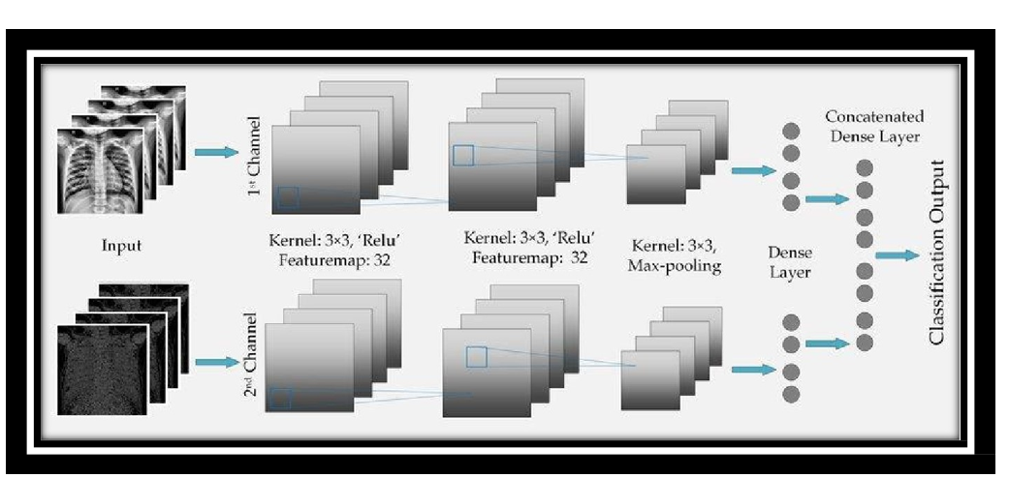

This architecture is a common and simple design for binary image classification tasks like pneumonia prediction. Here's a breakdown of the layers:

**Convolutional Layers (Conv2D):** Extracts features from input images using convolutional filters. The number of filters increases in deeper layers to capture more complex patterns. ReLU activation is used to introduce non-linearity. Max pooling is applied to down-sample the spatial dimensions.

**Flatten Layer:** Converts the multi-dimensional output from the convolutional layers into a one-dimensional array.Prepares the data for the fully connected layers.

**Dense (Fully Connected) Layers:** Neurons in these layers process information from the flattened representation. ReLU activation introduces non-linearity. Dropout is used for regularization to prevent overfitting.

**Output Layer:** Single neuron with a sigmoid activation function for binary classification (pneumonia or normal). Produces a probability indicating the likelihood of pneumonia. This architecture serves as a baseline, and depending on the dataset and task requirements, you may need to adjust the number of layers, neurons, or incorporate more advanced techniques such as transfer learning using pre-trained models like ResNet or DenseNet. Experimentation and fine-tuning are essential to optimize the CNN for the specific challenges presented by the pneumonia prediction task.

## DATA SET

The data set used in this work contains 5,863 chest x-ray images(from Kaggle). This dataset is further divided into test, train and validation images. These images in the dataset are further divided into two categories, they are namely normal and pneumonia infected images

Within the dataset, each chest x-ray image is categorized into one of two classes: normal or pneumonia-infected. This binary classification enables the algorithm to discern between healthy and diseased conditions, facilitating precise predictions. The inclusion of both categories in the dataset is fundamental for the algorithm to learn and distinguish relevant patterns associated with pneumonia within the context of chest

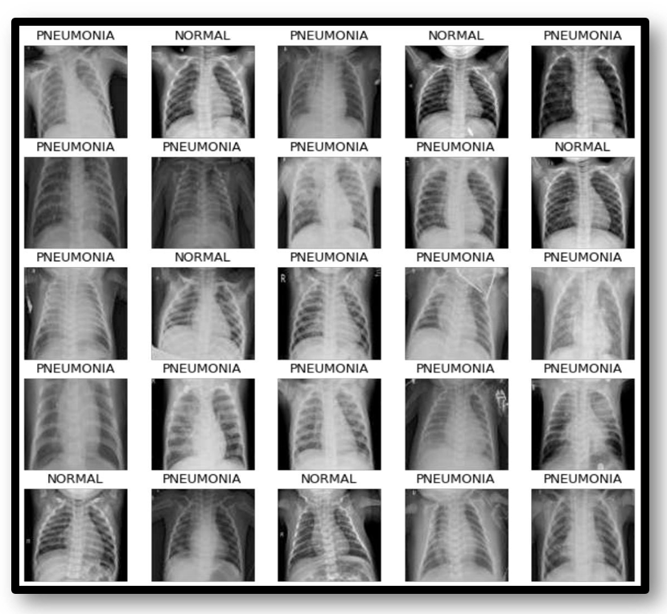

Figure 46. Data set for Pneumonia Detection

### DATA PREPROCESSING

In the preprocessing pipeline for pneumonia prediction using a Convolutional Neural Network (CNN), the initial step involves loading and organizing the chest x-ray image dataset into training, validation, and test sets. Data augmentation techniques, such as rotation, shearing, zooming, and horizontal flipping, are then applied to the training data, enhancing its diversity and aiding the model's generalization. Subsequently, pixel normalization rescales image values to a range of [0, 1], facilitating a stabilized training process. Data generators efficiently manage image loading and preprocessing in batches during model training and testing. Addressing class imbalances, if present, is an optional step through techniques like oversampling, under sampling, or using class weights. Additionally, model-specific preprocessing, such as utilizing specific normalization functions for pre-trained models like ResNet, ensures compatibility with the chosen CNN architecture. This comprehensive preprocessing strategy ensures that the input data is appropriately prepared, contributing to the effectiveness and reliability of the CNN in predicting pneumonia from chest x-ray images.

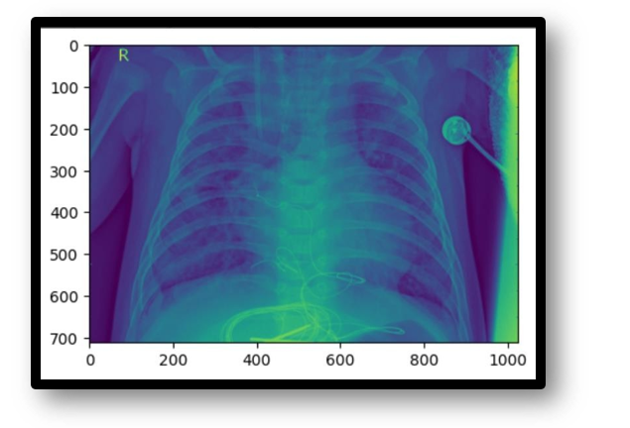

Figure 47. Loading the Data set of Pneumonia

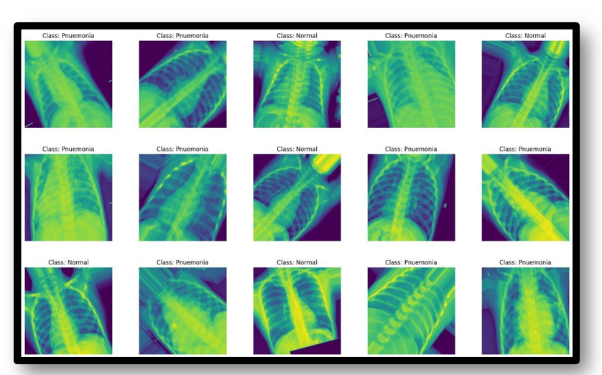

Figure 48. Data set for No Pneumonia Detection

Training the model: Initially the image data that is given as input will be divided into train, test and validation data . Training data is used to train the CNN algorithm in the model and to predict the output. Testing data is used to check if the functions produce the expected results for given inputs and also for negative testing. Validation checks to see how well the model responds to the new data and makes predictions on that data. Model creation : Each optimizer accepts at first the parameters of the model accessible via a self-taught model thought parameters. Fine tuning the model is done on the model.

Model : CNN Model Convolution neural network (CNN) assigns relative weights to different objects present in the image, and distinguishes between them. The ability of CNNs to construct an internal representation of a two-dimensional image is one of their advantages. This enables the model to learn location and scale in a variety of data forms, which is critical when working with photos. Among the most popular image analysis tasks for which CNN is used are picture identification, object detection, and segmentatioN

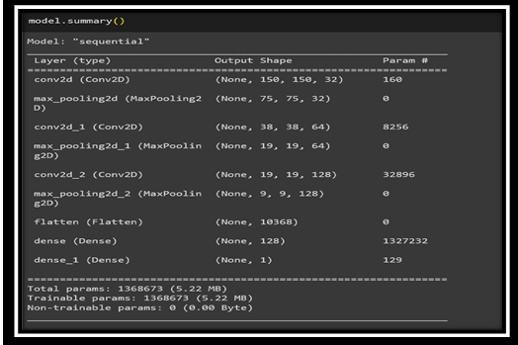

Figure 49. Summary of CNN Model for Pneumonia Detection

**EXPERIMENTAL RESULTS ANALYSIS**

Result Analysis Taking X-ray images as input and analyze the image using CNN ,gives output images with pneumonia or normal caption below them. Caption pneumonia indicates the person is having pneumonia and normal indicates the person is not suffering from pneumonia.

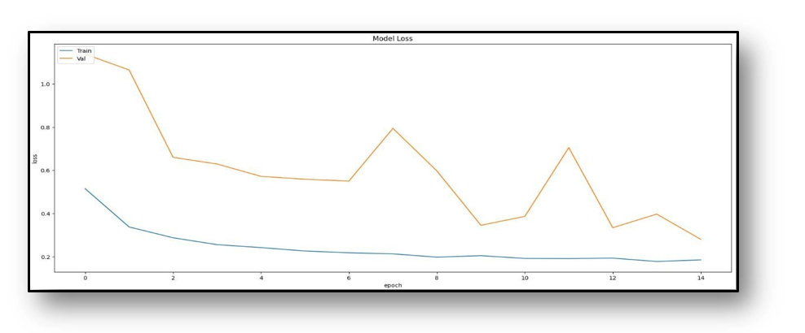

Figure 50. Plotting Training loss and Validation loss

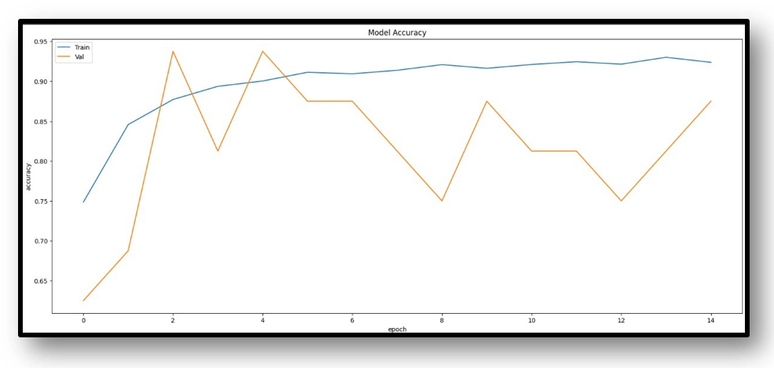Figure 51. Plotting Model Accuracy

**VALIDATION DATA**

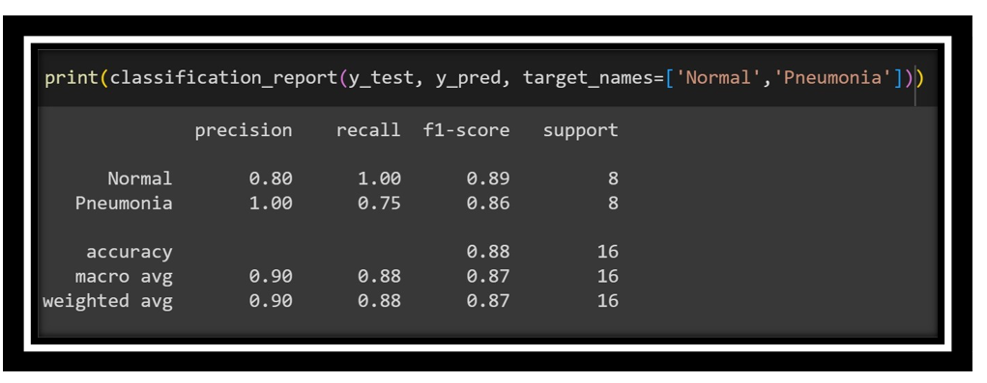

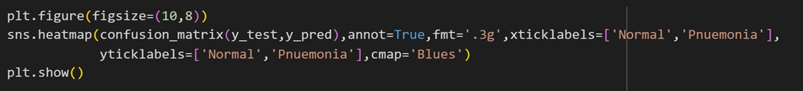

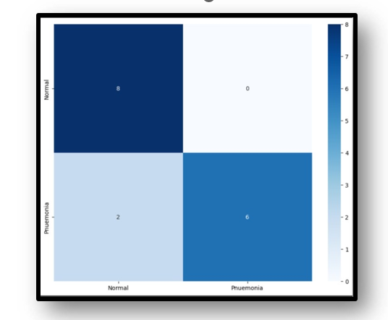

Figure 52. Plotting Heatmap of y_test and y_pred(traing data)

**TEST DATA**

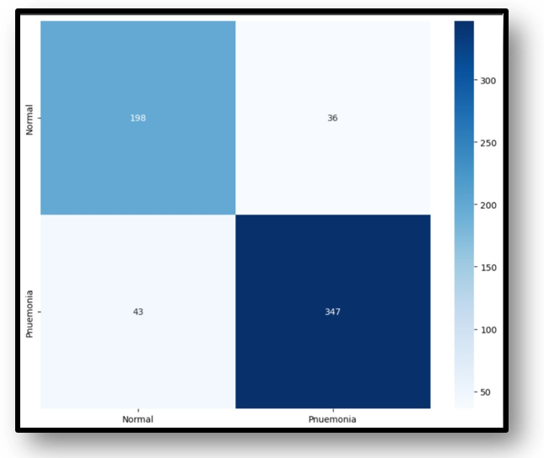

Figure 53. Plotting Heatmap of y_test and y_pred(test data)

|  |  |
| --- | --- |
| **CNN ACCURACY**  **FOR PNUEMONIA DETECTION** | **85%** |

Table. 11. CNN accuracy for pnuemonia prediction

**CHAPTER-7**

**TIMELINE FOR EXECUTION OF PROJECT**

**(GANTT CHART)**

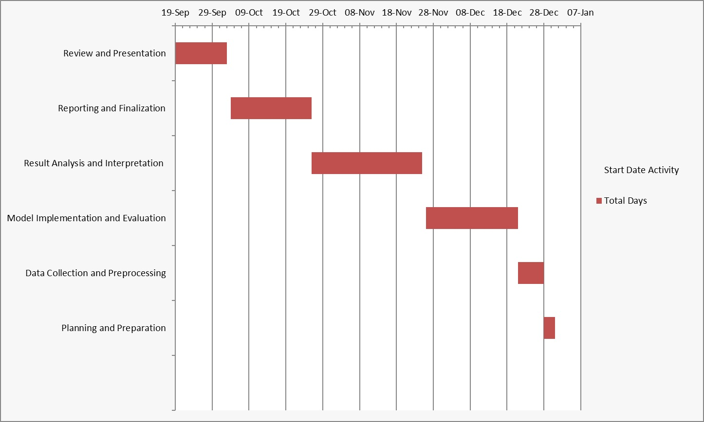

**CHAPTER-8**

**OUTCOMES**

The potential outcomes are as follows.

**1. Identification of Optimal Algorithms:**

Objective: Determine the best-performing machine learning algorithms for heart disease prediction.

Explanation: Through a comprehensive comparative analysis, this outcome allows for the identification of algorithms that demonstrate superior performance in accurately predicting heart disease risks. Healthcare professionals can leverage this information to choose models that align with their specific clinical requirements, optimizing diagnostic accuracy and patient care.

**2. Performance Metrics Insights**:

Objective: Provide detailed insights into performance metrics for each algorithm.

Explanation: This outcome offers a deeper understanding of performance metrics (such as accuracy, precision, recall, etc.) for each machine learning algorithm used in heart disease prediction. By highlighting strengths and weaknesses, healthcare practitioners gain valuable insights into the specific scenarios or patient demographics where each algorithm excels or falls short. These insights facilitate informed decision-making when selecting algorithms for real-world clinical applications.

**3. Model Interpretability:**

Objective: Offer insights into the interpretability of machine learning models.

Explanation: This outcome focuses on explaining how each algorithm generates predictions, ensuring that healthcare professionals can comprehend and trust the model's decision-making process. By providing insights into model interpretability, such as feature importance or decision rationale, it enhances the transparency and trustworthiness of the predictive models. Healthcare practitioners can better interpret and explain the predictions, fostering confidence in the model's utility and aiding in its adoption in clinical settings.

Each of these outcomes contributes significantly to the successful integration of machine learning models into clinical practice for heart disease prediction. They empower healthcare professionals with the necessary information and insights to make informed decisions, ultimately improving patient care and diagnostic accuracy.

**CHAPTER-9**

**DISCUSSION**

1. Key Findings and Implications

Our investigation into lifestyle disease prediction, employing robust machine learning models, unfolds critical insights into the susceptibility of individuals to heart disease, diabetes, chronic kidney disease (CKD), and pneumonia. These findings offer a nuanced understanding of the intricate interplay between individual health characteristics and the likelihood of developing these diseases.

2. Contextualizing Within Existing Knowledge

Aligning with the primary research questions, our results seamlessly integrate with the broader landscape of lifestyle disease research. A revisit to the literature review establishes a contextual framework, emphasizing the novelty and relevance of our predictive models within the existing body of knowledge.

3. Unveiling Patterns and Unexpected Outcomes

The analysis delves into unexpected outcomes, revealing unique correlations and patterns within our predictive models. By providing plausible interpretations for these surprises, we contribute to a deeper comprehension of the complexities inherent in lifestyle disease prediction.

4. Candid Exploration of Limitations

A candid discussion of research limitations enhances the credibility of our study. Addressing areas not covered provides a transparent foundation for future research, allowing refinement and improvement of predictive models.

5. Charting Future Research Trajectories

While acknowledging our study's contributions, we suggest potential avenues for future research. Grounded in identified gaps, these recommendations serve as a roadmap for researchers to explore uncharted territories in lifestyle disease prediction.

6. Concluding Significance and Broad Implications

The discussion concludes by reiterating the most significant findings and their implications. Emphasis is placed on the pivotal role of our research in advancing lifestyle disease prediction. Readers are reminded of the connections to existing literature and the broader impact on healthcare interventions and preventive measures.

**CHAPTER-10**

**CONCLUSION**

The application of machine learning, particularly in the form of predictive models, for lifestyle disease prediction has demonstrated significant potential across various health domains. In the case of diabetes, heart disease, chronic kidney disease, and pneumonia, these models offer valuable tools for early detection, intervention, and personalized healthcare.

For diabetes and heart disease, predictive models analyze diverse data sources, including patient health records, lifestyle factors, and genetic predispositions. These models can identify individuals at high risk, enabling healthcare providers to implement preventive measures and lifestyle interventions. The proactive approach facilitated by these models not only improves patient outcomes but also contributes to the optimization of healthcare resource allocation.

For Chronic Kidney Disease (CKD), our predictive model follows a similar proactive approach seen in models for diabetes and heart disease. By analyzing an array of data sources encompassing demographic details, physiological indicators, and lifestyle factors, our model excels in identifying individuals with an elevated risk of CKD. This foresightedness empowers healthcare providers to proactively implement preventive measures and lifestyle interventions, thereby enhancing patient outcomes. Moreover, the utilization of such predictive models contributes to the efficient allocation of healthcare resources, promoting an optimized and effective healthcare system.

Pneumonia prediction benefits significantly from machine learning, particularly in the analysis of chest x-ray images. Deep learning models, such as Convolutional Neural Networks (CNNs), can effectively discern patterns indicative of pneumonia, aiding clinicians in prompt diagnosis and treatment initiation. The speed and efficiency brought about by these models are particularly crucial in managing infectious diseases like pneumonia.

In conclusion, the utilization of machine learning in predicting lifestyle diseases proves transformative for healthcare. These models empower healthcare professionals with predictive insights, enabling early interventions, personalized treatment plans, and improved patient outcomes. As technology continues to advance, the integration of artificial intelligence in healthcare holds the promise of a more proactive, precise, and patient-centered approach to disease prevention and management. However, it is essential to address ethical considerations, data privacy, and ensure continuous refinement of these models through collaborative research and validation in real-world healthcare settings.

**REFERENCES**

1. Shraddha Subhash Shirsath, Prof. Shubhangi Patil Disease Prediction Using Machine Learn.Over Big Data”. International Journal of Innovative Research in Science, Engineering and Technology, [2018]. ISSN (Online) : 2319-8753, ISSN (Print) : 2347-6710.
2. Vinitha S, Sweetlin S, Vinusha H, Sajini S. “Disease Prediction Using Machine Learning Over Big Data”. Computer Science & Engineering: An International Journal (CSEIJ), Vol.8, No.1, [2018]. DOI:10.5121/cseij.2018.8101.
3. Sayali Ambekar and Dr.Rashmi Phalnikar. “Disease Prediction by using Machine Learning”. International journal of computer engineering and applications, Volume XII, special issue, May 18. ISSN: 2321-3469.
4. Lohith S Y, Dr. Mohamed Rafi. “Prediction of Disease Using Learning over Big Data - Survey”. International Journal on Future Revolution in Computer Science & Communication Engineering. ISSN:2454-4248.
5. J. Senthil Kumar, S. Appavu. “The Personalized Disease Prediction Care from Harm using Big Data Analytics in Healthcare”. Indian Journal of Science and Technology, vol 9(8), DOI:10.17485/ijst/2016/v9i8/87846, [2016]. ISSN (Print): 0974-6846, ISSN (Online): 0974-5645.
6. A Survey on Disease Prediction by Machine Learning over Big Data from Healthcare Communities International organization of Scientific Research 59 | Page Gakwaya Nkundimana Joel, S. Manju Priya. “Improved Ant Colony on Feature Selection and Weighted Ensemble to Neural Network Based Multimodal Disease Risk Prediction (WENN-MDRP) Classifier for Disease Prediction Over Big Data”. International Journal of Engineering & Technology, 7(3.27) (2018) 56-61.

1. Asadi Srinivasulu, S.Amrutha Valli, P.Hussain Khan, and P.Anitha. “A Survey on Disease Prediction in Big Data Healthcare using an Extended Convolutional Neural Network”. National conference on Emerging Trends in information, management and Engineering Sciences, [2018].
2. Stephen J.Mooney and Vikas Pejaver. “Big data in public health: Terminology, Machine Learning, and Privacy”, Annual Review of Public Health [2018]. Smriti Mukesh Singh, Dr. Dinesh B. Hanchate. “Improving Disease Prediction by Machine Learning”. eISSN: 2395-0056, p-ISSN:2395-0072.

1. Joseph, Nisha, and B. Senthil Kumar. "Top-K Competitor Trust Mining and Customer Behavior
2. Investigation Using Data Mining Technique."Journal of Network Communications and Emerging Technologies (JNCET) [www.](http://www/) jncet. org 8.2 (2018). Kumar, B. Senthil. "Adaptive Personalized Clinical Decision Support System Using Effective Data Mining Algorithms." Journal of Network Communications and Emerging Technologies (JNCET) www.jncet. org 8.1 (2018).
3. Unnikrishnan, Asha, and B. Senthil Kumar. "Biosearch: A Domain Specific Energy Efficient Query Processing and Search Optimization in Healthcare Search Engine." Journal of Network Communications and Emerging Technologies (JNCET) [www.](http://www/) jncet. org 8.1 (2017).
4. Kumar, B. Senthil. "Adaptive Personalized Clinical Decision Support System Using Effective Data Mining Algorithms." Journal of Network Communications and Emerging Technologies (JNCET) www.jncet. org 8.1 (2017).
5. Kumar, B. Senthil. "Data Mining Methods and Techniques for Clinical Decision Support Systems." Journal of Network Communications and Emerging Technologies (JNCET) [www.](http://www/) jncet. org 7.8 (2017). Communications and Emerging Technologies (JNCET) [www.](http://www/) jncet. org 7.8 (2017).
6. IEEE- International Conference On Advances In Engineering, Science And Management (ICAESM-2012) March 30,31,2012 2012-IEEE, Japan-Egypt Conference on Electronics, Communications and Computers.
7. Proceedings of the World Congress on Engineering and Computer Science Vol II WCECS 2014, 24 October, 2014, San Fransisco 2015 International Conference on Technologies for Sustainable Development (ICTSD- 2015) 6. International Journal on Recent and Innovation Trends in Computing and Communication| volume 2- 7. 20

**APPENDIX-A**

**PSUEDOCODE**

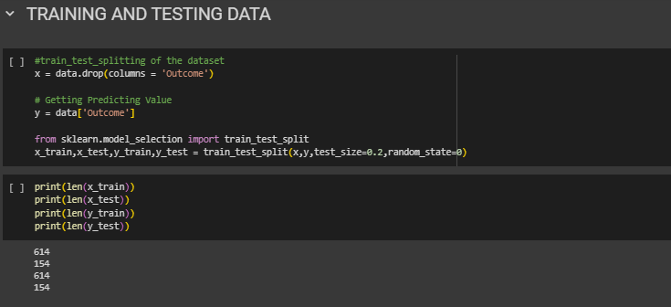

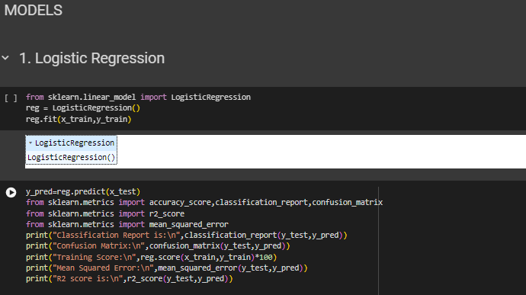

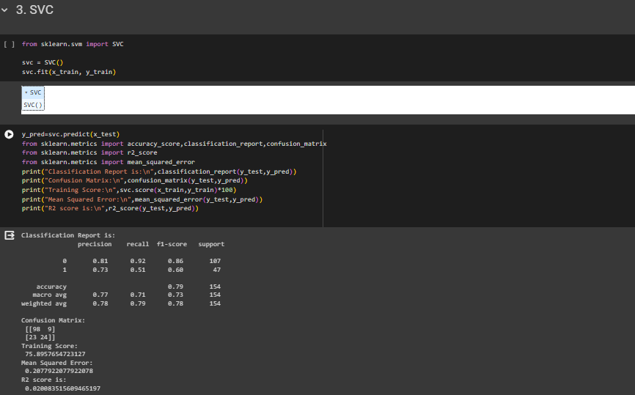

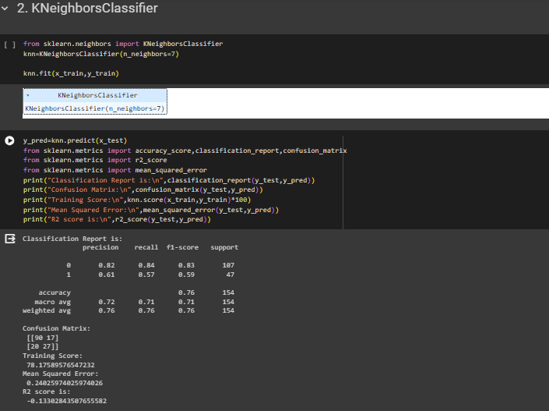

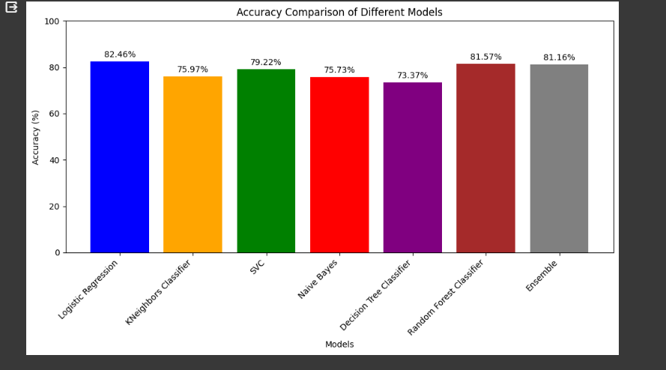

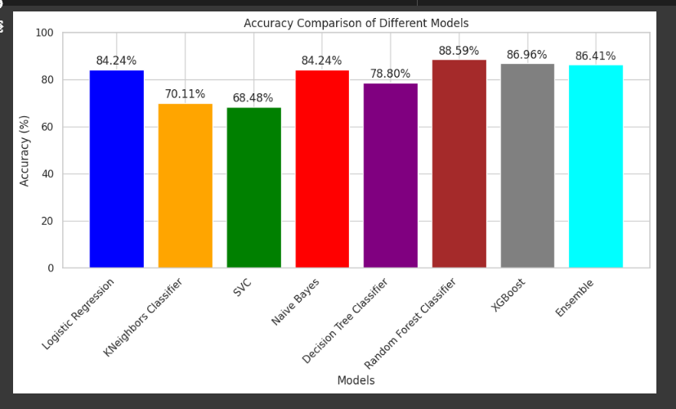

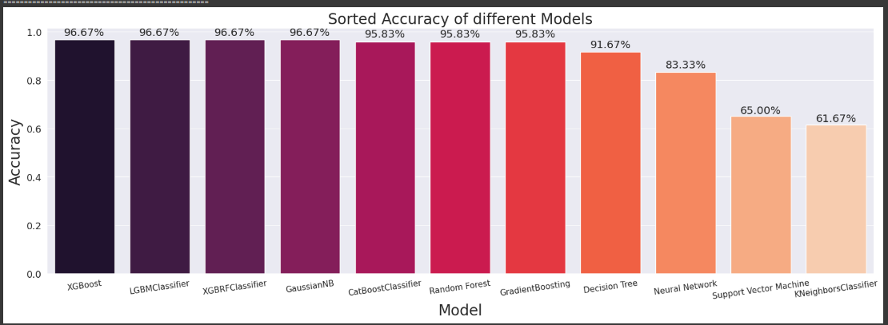

**APPENDIX-B**

**SCREENSHOTS**

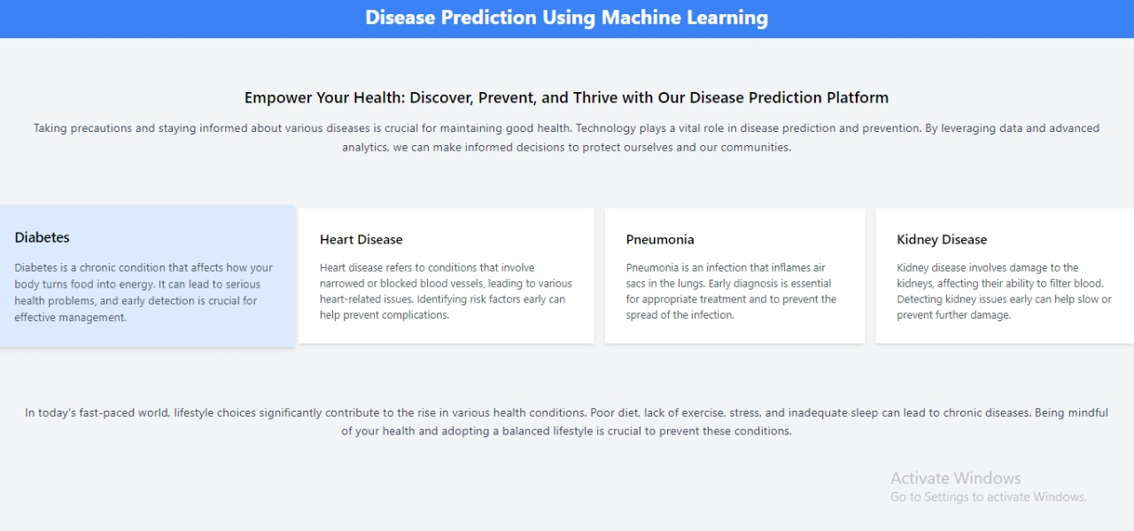

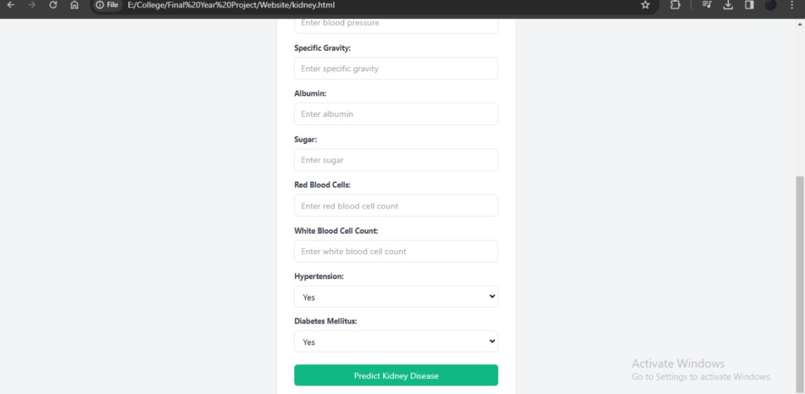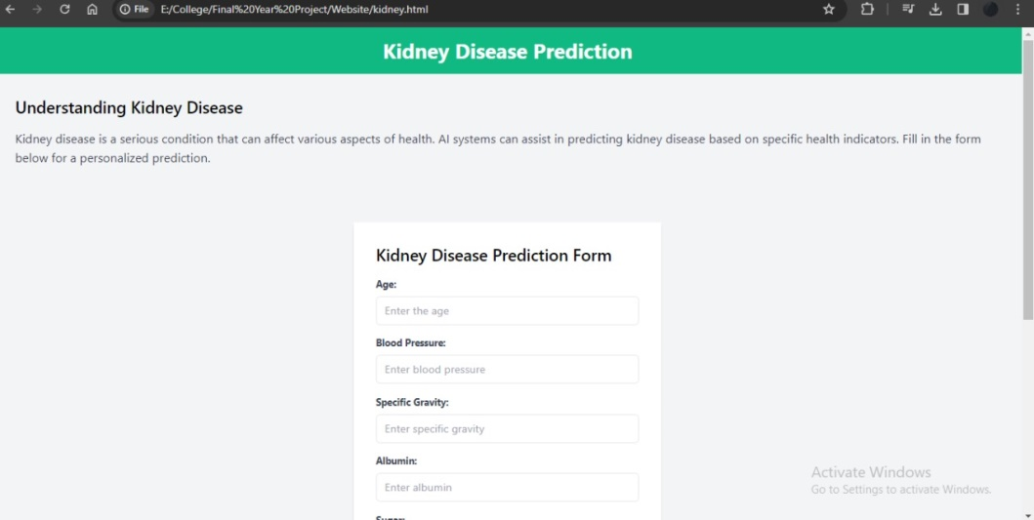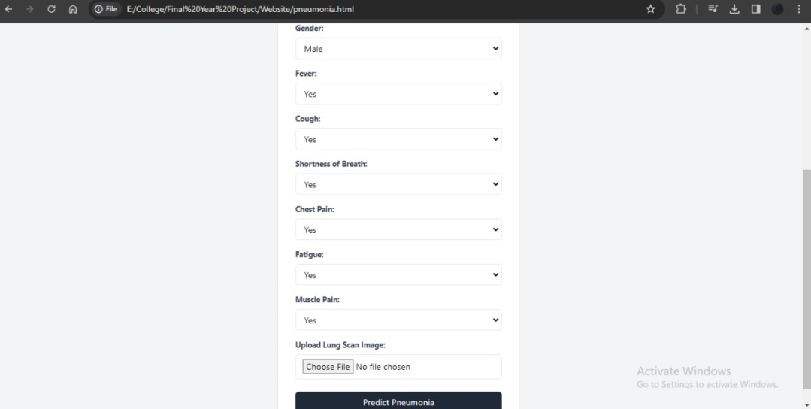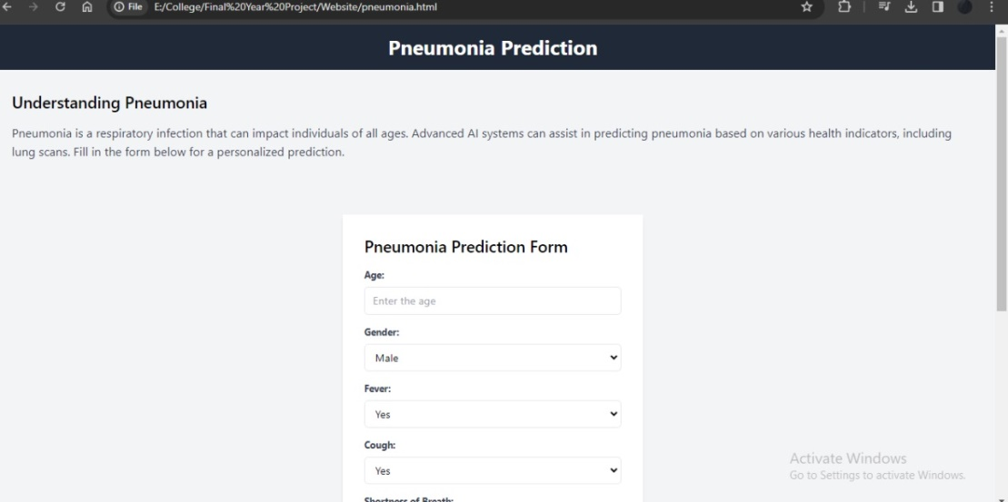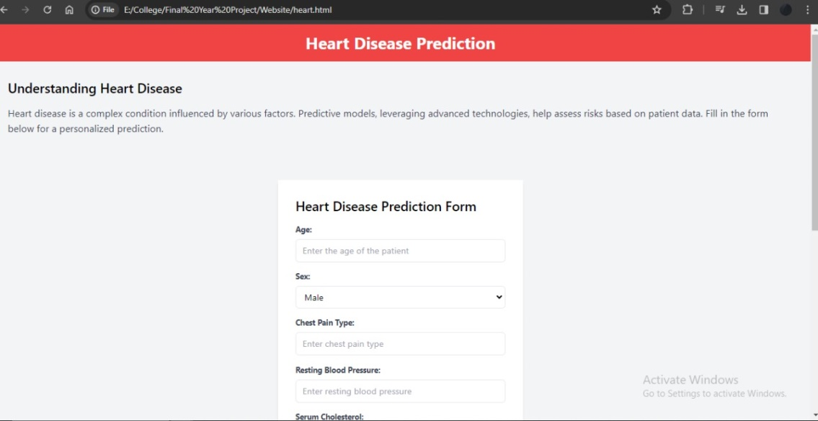

**APPENDIX-C**

**ENCLOSURES**

**1. Conference Paper Presented Certificates of all students.**

**2. Include certificate(s) of any Achievement/Award won in any project related event.**

**3. Similarity Index / Plagiarism Check report clearly showing the Percentage (%). No need of page-wise explanation.**